**Elaboration Phase Specification**

**CIS 320 – 02**

**Team: The Code Crusaders**

**Griffin Ford, Alex McIver, Rami Mohamed, Alex Allen, Jordan Neal, Jacob Palmer**



Table of Contents

1. System Requirements 3

1.1 Requirements Narrative 3

1.2 Functional Requirements 3

1.2.A Customer Account Requirements 3

1.2.B Trip Details Requirements 3

1.2.C Trip Search Requirements 4

1.2.D End-of-Year Email Requirements 4

1.2.E Trip Booking Requirements 4

1.3 Non-functional Requirements 5

2. Use Cases 5

3. Trace Matrix 66

4. Class Diagram & Narrative 67

5. Database Diagram & Narrative 68

6. Database Definitions 69

**7**.User Interface Navigation Diagram & Narrative 72

8. Screen Layouts 72

8.3A Search Screens/Forms 72

8.3B Profile Screens/Forms 74

8.3C Cart Screens/Forms 75

**9**.Gantt Chart 75

10. Physical Architecture Design 77

**1**1. Design Procedures for Security Concerns & Nonfunctional Requirements 78

# 1. System Requirements

## 1.1 Requirements Narrative

For the system to function at the highest level and fulfill all goals specified in the vision document. There are a variety of different requirements to complete the system's objectives. Section 4.2 lays out all the requirements divided into different sections based on their objective. All the requirements in 4.2 are the functional requirements of the system. These are the functions that the system needs to have. In section 4.3 is all the Non-functional requirements. These requirements don’t correlate to the features needed to build the system.

## 1.2 Functional Requirements

### 1.2.A Customer Account Requirements

FR001: Customer shall be able to create an initial account.

FR002: Customer shall be able to update account.

FR003: Customer shall be able to delete account.

FR004: Customer shall be able to add payment method.

FR005: Customer shall be able to update payment method.

### 1.2.B Trip Details Requirements

FR006: Guidebook employees shall be able to add Pro trips.

FR007: GuideBook employee shall be able to update Pro trip details.

FR008: GuideBook employee shall be able to delete Pro trips.

FR009: Customer shall be able to click links to flight websites.

FR010: Customer shall be able to click links to living arrangement booking websites.

FR011: Customer shall be able to click links to Pro guide’s social media.

FR012: Customer shall be able to submit text and pictures about their experiences.

### 1.2.C Trip Search Requirements

FR013: Customer shall be able to search for Pro trips by fish.

FR014: Customer shall be able to search for Pro trips by destination.

FR015: Customer shall be able to search for Pro trips by Guide.

FR016: Customer shall be able to search for non-Pro trips by toggling access to them while searching.

FR017: Non-Pro trips shall display warning that current trip is not a Pro trip.

FR018: Non-Pro trips shall display how many Pro trips that user can still book.

### 1.2.D End-of-Year Email Requirements

FR019: Email system shall display customer’s highlights of the year

FR020: Email system shall display GuideBook’s highlights and records for the year

FR021: Email system shall provide invite link for customer to invite a friend to GuideBook Pro

### 1.2.E Trip Booking Requirements

FR022: Customer shall be able to book trip.

FR023: Customer shall be able to submit payment for trip

FR024: Customer shall be sent email confirmation for trip.

FR025: Customer shall be sent email confirmation for trip.

FR026: Customer shall be sent email that is customized/written by guide.

FR027: Guide shall be able to customize the email that is sent after a user books their trip.

FR028: Administrator shall be able to respond to Customer Questions.

FR029: Guide shall be able to create an initial account.

FR030: Guide shall be able to update their account.

FR031: Customer shall be able to access Guidebook Pro features through the Guidebook base website.

## 1.3 Non-functional Requirements

NFR001: Website shall be available 24/7 to users.

NFR002: Website page shall load within 5 seconds.

NFR003: Website shall function on mobile/app.

NFR004: Stripe shall maintain a secure payment system.

# 2. Use Cases

**Use Case Description 1: Creates Account**

|  |  |  |
| --- | --- | --- |
| **Use Case Name**: Creates Account | **ID**: 01 | **Importance Level**: Low |
| **Primary Actor**: Customer | | **Use Case Type**: Detail, Essential |
| **Stakeholders and Interests**:   * ***Customer:*** wants to create an account * ***GuideBook Pro:*** tool used create account | | |
| **Brief Description**: Customer logs in to GuideBook Pro and sets up account | | |
| **Trigger**: User clicks on ‘Sign Up’ button in GuideBook Pro site  **Type**: External | | |
| **Relationships**:  *Customer with Website* | | |
| **Normal Flow of Events:**   1. The customer logs onto GuideBook Pro. 2. The customer clicks on create an account 3. The customer then enters their information into the form 4. Account is created | | |
| **Alternate/Exceptional Flows:**  1a. User has account already  2a. User enters invalid information | | |

**Sequence Diagrams: Use Case 1**

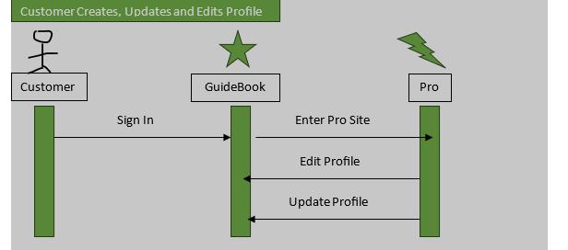

### **Use Case Description 02: Updates Account**

|  |  |  |
| --- | --- | --- |
| **Use Case Name**: Updates Account | **ID**: 02 | **Importance Level**: Medium |
| **Primary Actor**: Customer | | **Use Case Type**: Detail, Essential |
| **Stakeholders and Interests**:   * ***Customer:*** wants to update account * ***GuideBook Pro:*** tool used to edit account | | |
| **Brief Description**: Customer updates their profile information | | |
| **Trigger**: User clicks on ‘Edit Profile’ button in GuideBook Pro site Account Tab  **Type**: External | | |
| **Relationships**:  *Customer with Website* | | |
| **Normal Flow of Events:**   1. The customer logs onto GuideBook Pro. 2. The customer clicks on their account information 3. The customer then clicks edit information 4. Account is updated | | |
| **Alternate/Exceptional Flows:**  1a. User enters invalid information | | |

**Sequence Diagrams: Use Case 2**



### **Use Case Description 03: Adds Payment**

|  |  |  |
| --- | --- | --- |
| **Use Case Name**: Adds Payment | **ID**: 03 | **Importance Level**: High |
| **Primary Actor**: Customer | | **Use Case Type**: Detail, Essential |
| **Stakeholders and Interests**:   * ***Customer:*** wants to add payment information * ***GuideBook Pro:*** tool used to edit account | | |
| **Brief Description**: Customer adds payment information to their profile | | |
| **Trigger**: User goes to pay subscription fee to GuideBook Pro and has to enter a form of payment.  **Type**: External | | |
| **Relationships**:  *Customer with Website* | | |
| **Normal Flow of Events:**   1. The customer logs on to GuideBook Pro 2. The customer is asked to pay subscription fee 3. The customer then adds payment information 4. The customer then pays subscription fee | | |
| **Alternate/Exceptional Flows:**  1a. User enters invalid information | | |

### **Sequence Diagrams: Use Case 3**



### **Use Case Diagrams 01 - 03: Customer Creates, Updates, and Edits Account**

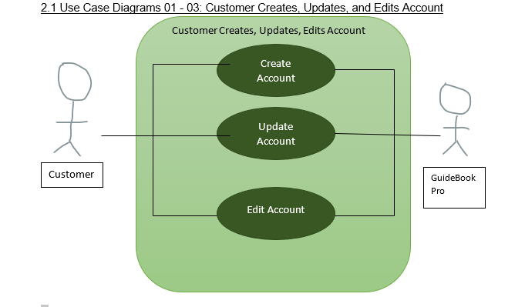

**Use Case Diagram Narratives**

A user can create, update and edit their account. This will allow a user to make sure that their account information is correct. This will allow GuideBook Pro to contact the right information when they need to get in touch. This also allows a user to edit any information about their account that they want to edit, in case that they change emails or credit cards or anything of that nature.

### **Use Case Description 04: Pays Subscription**

|  |  |  |
| --- | --- | --- |
| **Use Case Name**: Pays Subscription | **ID**: 04 | **Importance Level**: High |
| **Primary Actor**: Customer | | **Use Case Type**: Detail, Essential |
| **Stakeholders and Interests**:   * ***Customer:*** wants to pay subscription fee * ***GuideBook Pro:*** tool used to edit account | | |
| **Brief Description**: Customer pays for their yearly subscription fee to Pro | | |
| **Trigger**: Customer goes to pay subscription fee to GuideBook Pro  **Type**: External | | |
| **Relationships**:  *Customer with Website* | | |
| **Normal Flow of Events:**   1. The customer logs on to GuideBook Pro 2. The customer is asked to pay subscription fee 3. The customer then adds payment information 4. The customer then pays subscription fee | | |
| **Alternate/Exceptional Flows:**  1a. User enters invalid information | | |

**Sequence Diagrams: Use Case 4**

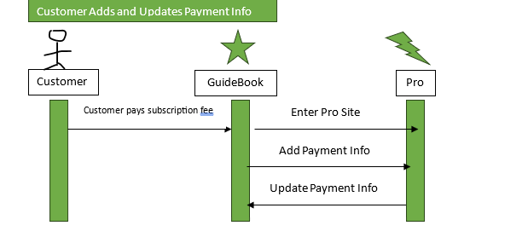

### **Use Case Description 05: Updates Payment**

|  |  |  |
| --- | --- | --- |
| **Use Case Name**: Updates Payment | **ID**: 05 | **Importance Level**: High |
| **Primary Actor**: Customer | | **Use Case Type**: Detail, Essential |
| **Stakeholders and Interests**:   * ***Customer:*** wants to update payment information * ***GuideBook Pro:*** tool used to edit account | | |
| **Brief Description**: Customer updates payment information in their profile | | |
| **Trigger**: Customer clicks on edit payment information tab in their profile  **Type**: External | | |
| **Relationships**:  *Customer with Website* | | |
| **Normal Flow of Events:**   1. The customer logs on to GuideBook Pro 2. The customer clicks on their profile 3. The customer clicks on ‘edit payment information’ button under their information 4. The customer then updates payment information | | |
| **Alternate/Exceptional Flows:**  1a. User enters invalid information | | |

**Sequence Diagrams: Use Case 5**



### **Use Case Diagrams 04 - 05: Customer Enters and Updates Payment Information**

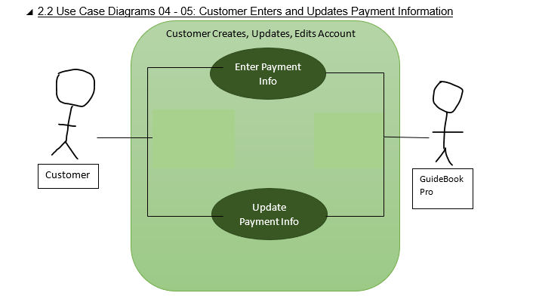

**Use Case Narrative**

These two use cases will allow a user to enter and update their payment information. Along with Use Cases 1-3, this will ensure that the user can keep their payment information accurate and up to date and ensure GuideBook Pro can charge a correct and valid credit card.

### **Use Case Description 6: Pays Deposit**

|  |  |  |  |
| --- | --- | --- | --- |
| Use Case Name: Pays Deposit | ID: 06 | | Importance Level: High |
| Primary Actor: Customer | | Use Case Type: Detail, Essential | |
| Stakeholders and Interests:  Customer: Wants to upgrade to Guidebook Pro and pay the deposit.  Website: Tool used to facilitate the payment process.  Payment Processor: Tool used to securely process payment transactions. | | | |
| Brief Description: This use case describes how a customer can upgrade to Guidebook Pro by paying the required deposit. | | | |
| Trigger: Customer selects the option to upgrade to Guidebook Pro.  Type: External | | | |
| Relationships:  Association: Customer  Include: None  Extend: None  Generalization: Upgrading to Guidebook Pro | | | |
| Normal Flow of Events:  Customer logs into their account on the website.  Customer navigates to the subscription upgrade section.  Customer selects the option to upgrade to Guidebook Pro.  The system presents the pricing and terms of the Guidebook Pro subscription.  Customer confirms their decision to upgrade and proceed with the payment.  The system prompts the customer to enter their payment details.  Customer provides their payment information (credit/debit card details, PayPal account, etc.).  The system securely processes the payment transaction.  Upon successful payment processing, the system updates the customer's account status to indicate Guidebook Pro subscription.  The system confirms the successful payment to the customer.  Customer gains access to Guidebook Pro features. | | | |
| Alternate/Exceptional Flows:  6a. Invalid Payment Information: If the customer provides invalid payment information, the system prompts them to correct the errors and resubmit the payment details.  Sub flows: None | | | |

Use case 6: Sequence diagram

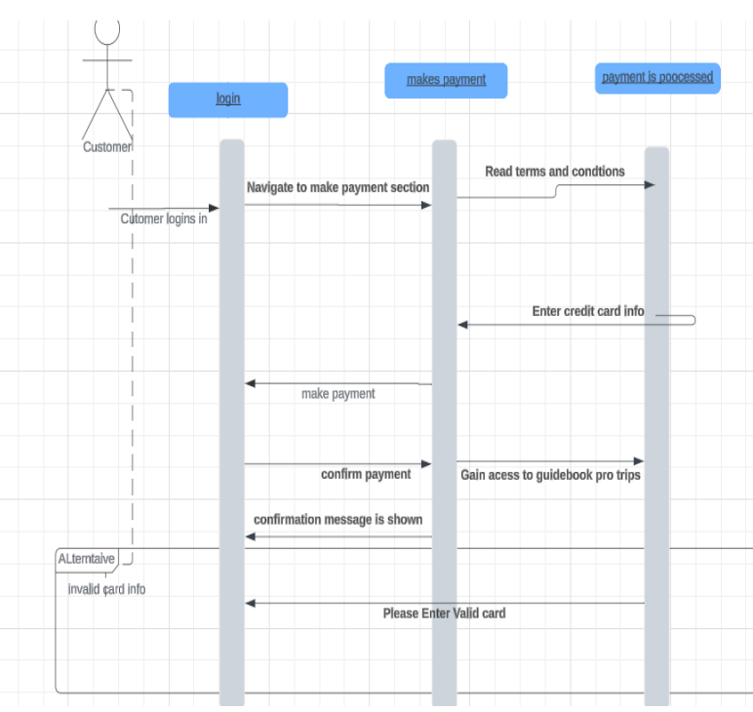

**Use Case Diagram 6: Pays Deposit**

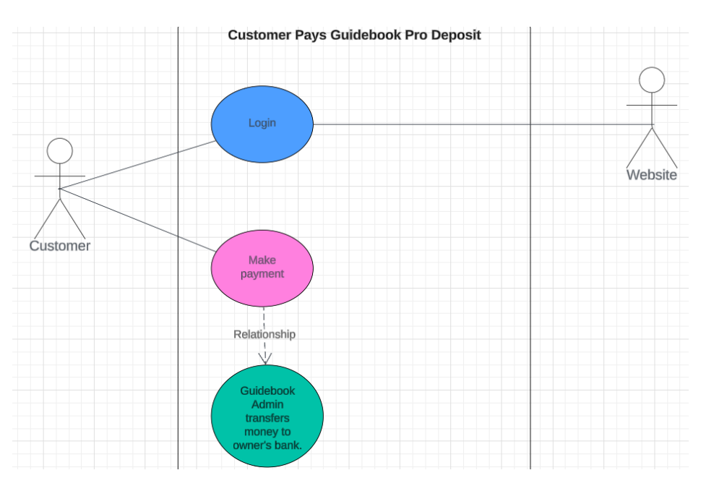

**Use case narrative:**

This use case will allow the customer to pay a deposit once they subscribe. Once the customer pays, the admin will be able to transfer money to the owners of guidebook. This allows a smooth and safe transaction between customers' payment and owners receiving money.

**Use Case Description 7: Searches by Destination**

|  |  |  |  |
| --- | --- | --- | --- |
| Use Case Name: Searches by Destination | ID: 07 | Importance Level: Medium | |
| Primary Actor: Customer | | | Use Case Type: Detail, Essential |
| Stakeholders and Interests:  Customer: Wants to efficiently find destinations of interest.  Website: Aims to provide a user-friendly search experience to enhance customer satisfaction.  Search Engine: Needs to deliver accurate and relevant search results to the customer. | | | |
| Brief Description:  This use case describes the process by which a customer searches for travel destinations on the website. | | | |
| Trigger: The customer initiates a search query for destinations.  Type: External | | | |
| Relationships:  Association: Customer  Include: None  Extend: None  Generalization: None | | | |
| Normal Flow of Events:  The customer logs into their account on the website.  The customer navigates to the search section of the website.  The customer enters their desired destination into the search bar.  The system retrieves relevant destinations matching the customer's query.  The system displays the search results to the customer.  The customer selects a destination from the search results to view detailed information. | | | |
| SubFlows: None Identified  Alternate/Exceptional Flows:  1a. Login Failure:  The customer fails to log in due to incorrect credentials.  The system prompts the customer to retry or reset their password.  4a. No Search Results:  There are no destinations matching the customer's query.  The system notifies the customer and prompts them to refine their search criteria. | | | |

**Use Case 7: Sequence Diagram**

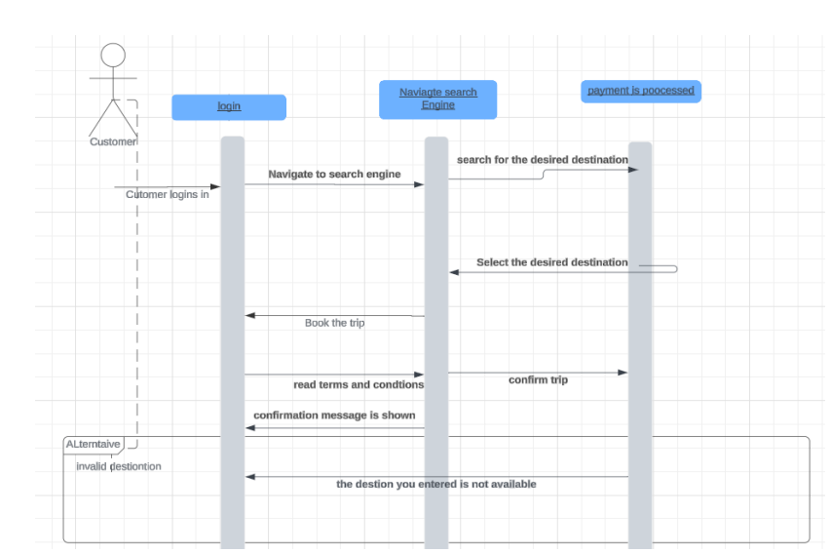

**Use Case Diagram 7: Searches by Destination**

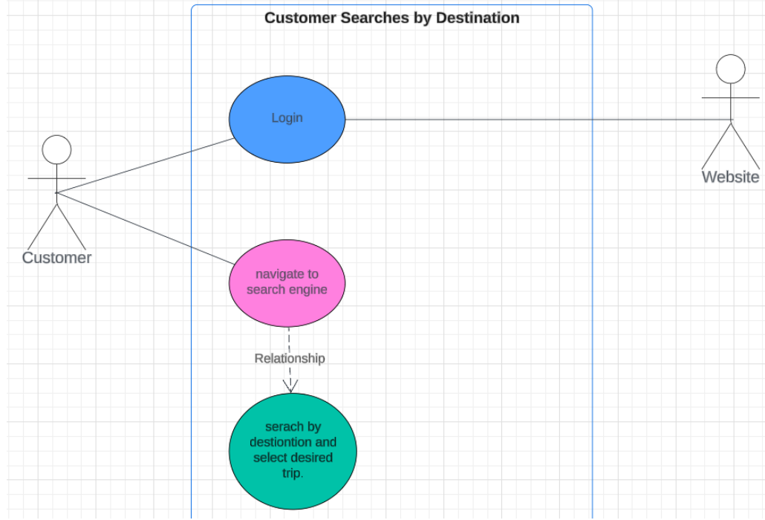

**Use case narrative:**

This use case allows customers to login and search for the trip they desire based on what destination they want. They can search by the closest destination or a destination they haven’t experienced yet. Searching by destination narrows it down for customers to easily search and book the trip they want.

**Use Case Description 8: Search by Fish**

|  |  |  |  |
| --- | --- | --- | --- |
| Use Case Name: Searches by Fish | ID: 08 | Importance Level: Low | |
| Primary Actor: Customer | | | **Use Case Type**: Detail, Essential |
| Stakeholders and Interests:  Customer: Wants to find relevant information about fish.  Website: Provides the search functionality and retrieves search results.  Search Engine: Executes the search query and returns relevant results to the customer. | | | |
| Brief Description:  This use case describes how a customer can search for information related to fish on the website. | | | |
| Trigger: Customer enters "fish" in the search bar and submits the search query.  Type: External | | | |
| Relationships:  Association: Customer  Include: None  Extend: None  Generalization: None | | | |
| **Normal Flow of Events:**  The customer navigates to the website's search bar.  The customer enters "fish" in the search bar.  The customer submits the search query.  The website processes the search query.  The search engine retrieves relevant search results.  The website displays the search results to the customer.  The customer reviews the search results and selects a specific item of interest. | | | |
| **Sub flows:** None Identified  **Alternate/Exceptional Flows:**  Invalid Search Query: If the search query is too broad or ambiguous, the website prompts the customer to refine their search.  No Search Results: If there are no search results matching the customer's query, the website notifies the customer and suggests alternative search terms. | | | |

**Use Case 8: Sequence Diagram**

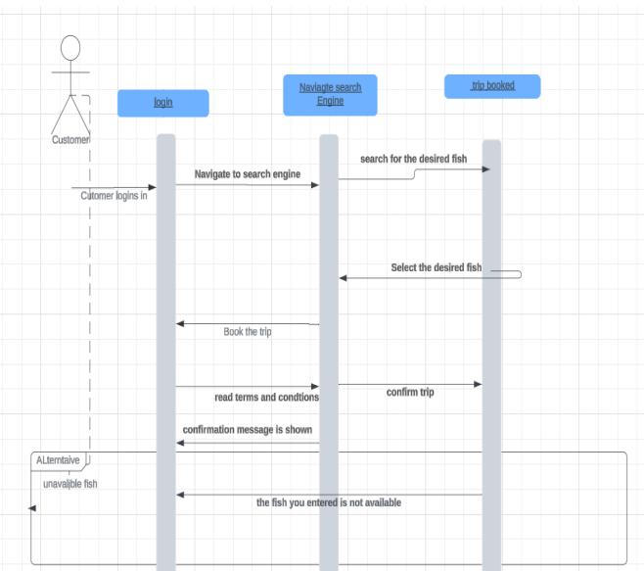

**Use Case Diagram 8: Search by Fish**

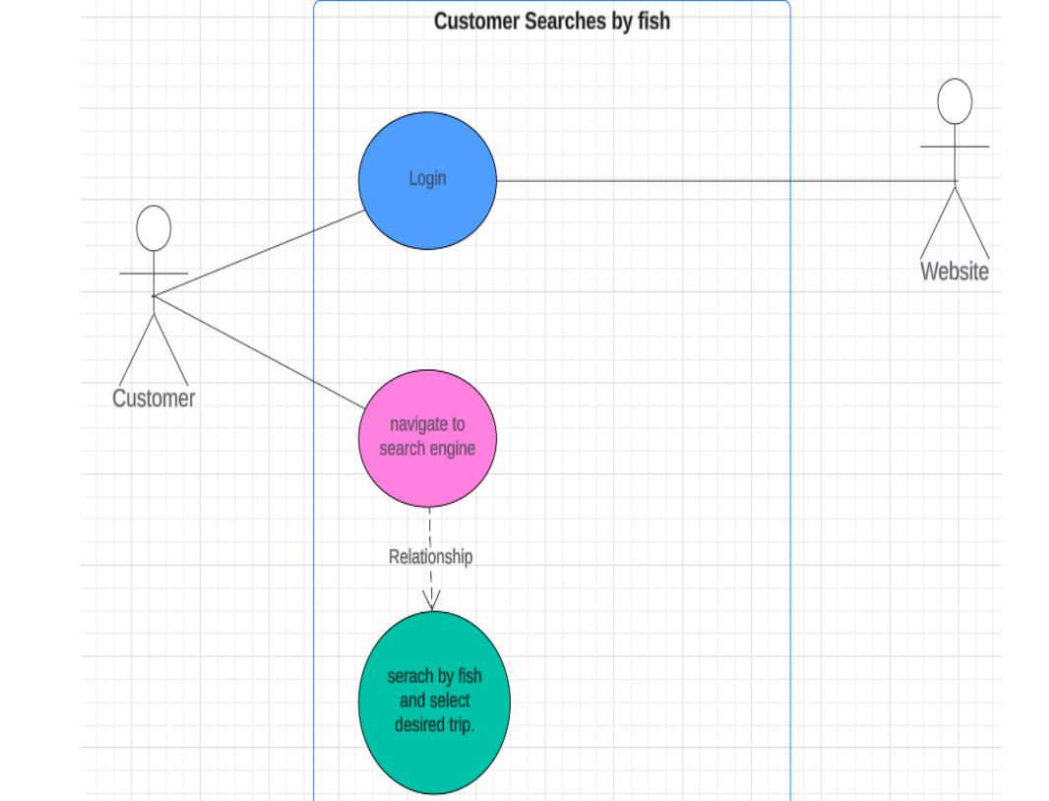

**Use case narrative:**

This use case allows customers to login and search for the trip they desire based on what fish they want. They can search by a fish they never caught. Searching by fish narrows it down for customers to easily search and book the trip they want.

**Use Case Description 9: Search by Guide**

|  |  |  |  |
| --- | --- | --- | --- |
| Use Case Name: Customer Searches by Guide | ID: 9 | Importance Level: Low | |
| Primary Actor: Customer | | | Use Case Type: Detail, Essential |
| Stakeholders and Interests:  Customer: Wants to find information about guides.  Website: Provides the search functionality and retrieves search results.  Search Engine: Executes the search query and returns relevant results to the customer. | | | |
| Brief Description:  This use case describes how a customer can search for information related to guides on the website. | | | |
| Trigger: Customer enters "guide" in the search bar and submits the search query.  Type: External | | | |
| Relationships:  Association: Customer  Include: None  Extend: None  Generalization: None | | | |
| Normal Flow of Events:  The customer navigates to the website's search bar.  The customer enters "guide" in the search bar.  The customer submits the search query.  The website processes the search query.  The search engine retrieves relevant search results related to guides.  The website displays the search results to the customer.  The customer reviews the search results and selects a specific guide of interest. | | | |
| SubFlows: None Identified  Alternate/Exceptional Flows:  Invalid Search Query: If the search query is too broad or ambiguous, the website prompts the customer to refine their search.  No Search Results: If there are no search results matching the customer's query, the website notifies the customer and suggests alternative search terms. | | | |

**Use Case Description 10: Selects/Books Trip**

|  |  |  |  |
| --- | --- | --- | --- |
| Use Case Name: Selects/Books Trip | ID: 10 | Importance Level: Medium | |
| Primary Actor: Customer | | | Use Case Type: Detail, Essential |
| Stakeholders and Interests:  Customer: Wants to browse and select a trip for booking.  Website: Provides the interface for browsing and selecting trips.  Trip Provider: Offers various trips for customers to select from. | | | |
| Brief Description:  This use case describes how a customer selects a trip from the available options provided by the website. | | | |
| Trigger: Customer navigates to the trips section of the website and selects a specific trip.  Type: External | | | |
| Relationships:  Association: Customer  Include: None  Extend: None  Generalization: None | | | |
| **Normal Flow of Events:**  The customer navigates to the trips section of the website.  The website displays a list of available trips to the customer.  The customer browses through the list of trips.  The customer selects a specific trip from the list.  The website processes the selection and provides additional details about the selected trip.  The customer reviews the details of the selected trip and confirms their choice. | | | |
| SubFlows: None Identified  **Alternate/Exceptional Flows:**  No Trips Available: If there are no trips currently available, the website notifies the customer and suggests checking back later or exploring other options.  Error Processing Selection: If there is an error processing the customer's selection, the website notifies the customer and prompts them to try again later or contact customer support for assistance. | | | |

**Use Case 9-10: Sequence Diagram**

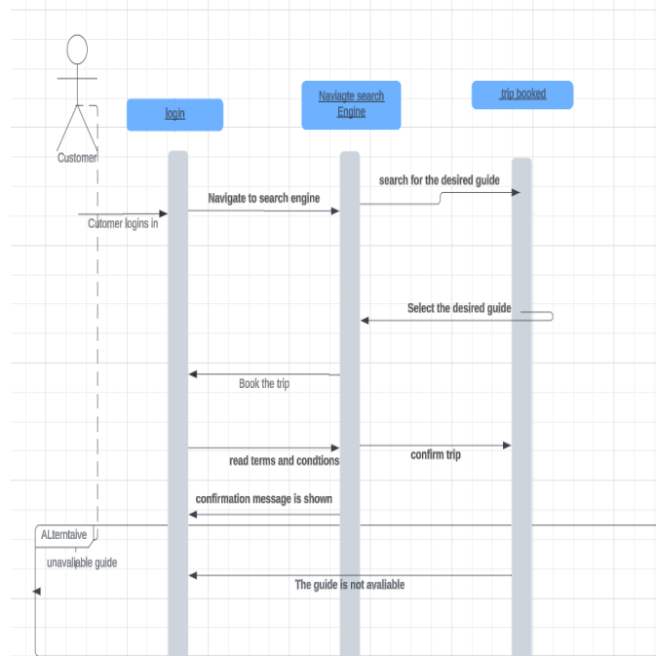

**Use Case** **Diagram 9: Search by Guide**

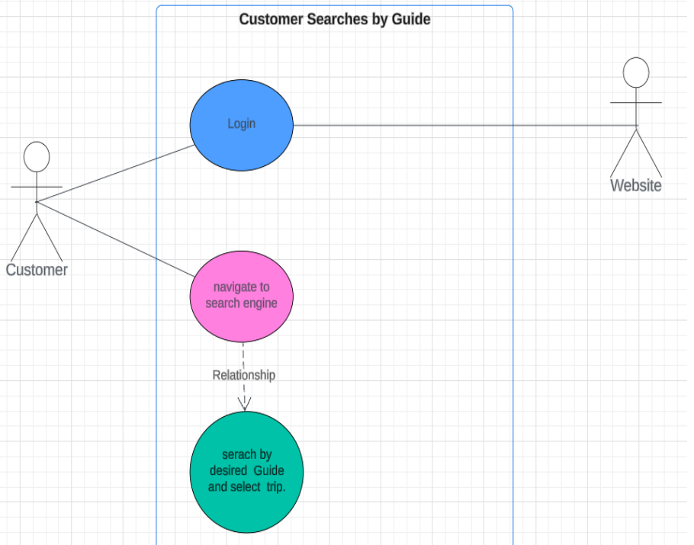

**Use case narrative:**

There are some customers who prefer to go with a guide who has a lot of experience or someone who they have already gone with. This is where being able to search by the guide you would like to go with can be useful and makes the trip easy to find and book for customers.

**Use Case Description 10: Selects/Books Trip**

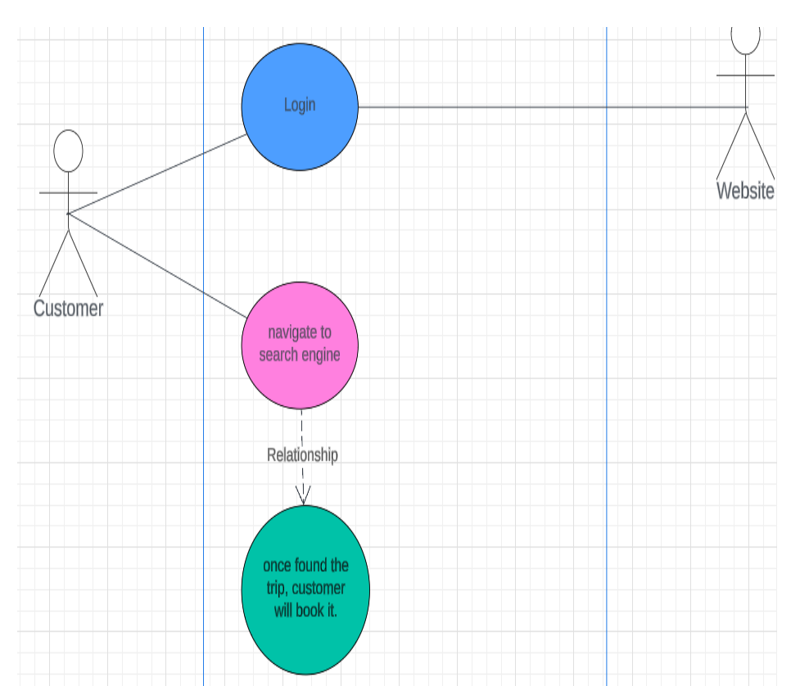

**Use case narrative:**

This use case allows customers to book a trip they desire once they find it. Once they book the trip, they will receive a confirmation email.

**Use Case Description 11: Clicks Travel Link**

|  |  |  |
| --- | --- | --- |
| **Use Case Name**: Clicks Travel Link | **ID**: 11 | **Importance Level**: Low |
| **Primary Actor**: Customer | | **Use Case Type**: Detail, Essential |
| **Stakeholders and Interests**:   * **Customer:** wants to be directed to external site to make travel accommodations for their trip * **Administrator:** wants to ensure that links automatically query for accommodations near the trip location and for the trip’s dates * **GuideBook:** wants to earn commission on travel bookings | | |
| **Brief Description**: This describes how a customer can click links or widgets on the trip details page to external travel accommodation sites that are queried according to the trip’s location and date | | |
| **Trigger**: User clicks on travel site links or widgets on a trip details page  **Type**: External | | |
| **Relationships**:  Association: Customer  Include:  Extend: Use Case 10: Customer Selects Trip  Generalization: | | |
| **Normal Flow of Events:**   1. After booking a trip, customer clicks on a link or widget to a travel accommodation site. 2. External site is automatically queried according to trip location and date. 3. Customer books accommodations on external site. 4. GuideBook earns commission when trip is taken. | | |
| **SubFlows:**  1a. Customer inputs querying information into travel widget. | | |
| **Alternate/Exceptional Flows:**  1a. Customer clicks on travel link/widget before booking trip.  2a. Automatic querying fails, customer searches for trip manually.  3a. Customer does not book any accommodations. | | |

**Use Case Description 12:Clicks Social Media Link**

|  |  |  |
| --- | --- | --- |
| **Use Case Name**: Clicks Social Media Link | **ID**: 12 | **Importance Level**: Low |
| **Primary Actor**: Customer | | **Use Case Type**: Detail, Essential |
| **Stakeholders and Interests**:   * **Customer:** wants to be directed to guide’s social media * **Administrator:** wants to ensure that links work correctly and lead to guide’s social media * **Guide:** wants to ensure customers are directed to their social media | | |
| **Brief Description:** This describes how a customer can click links on the trip details page (under guide’s summary profile) to the guide’s social media accounts. | | |
| **Trigger**: User clicks on social media links on a trip details page  **Type**: External | | |
| **Relationships**:  Association: Customer  Include:  Extend:  Generalization: | | |
| **Normal Flow of Events:**   1. While viewing a trip details page, customer clicks link to guide’s social media. 2. Customer is directed to guide’s social media. | | |
| **SubFlows:** | | |
| **Alternate/Exceptional Flows:** | | |

**Use Case 11-12: Sequence Diagram**

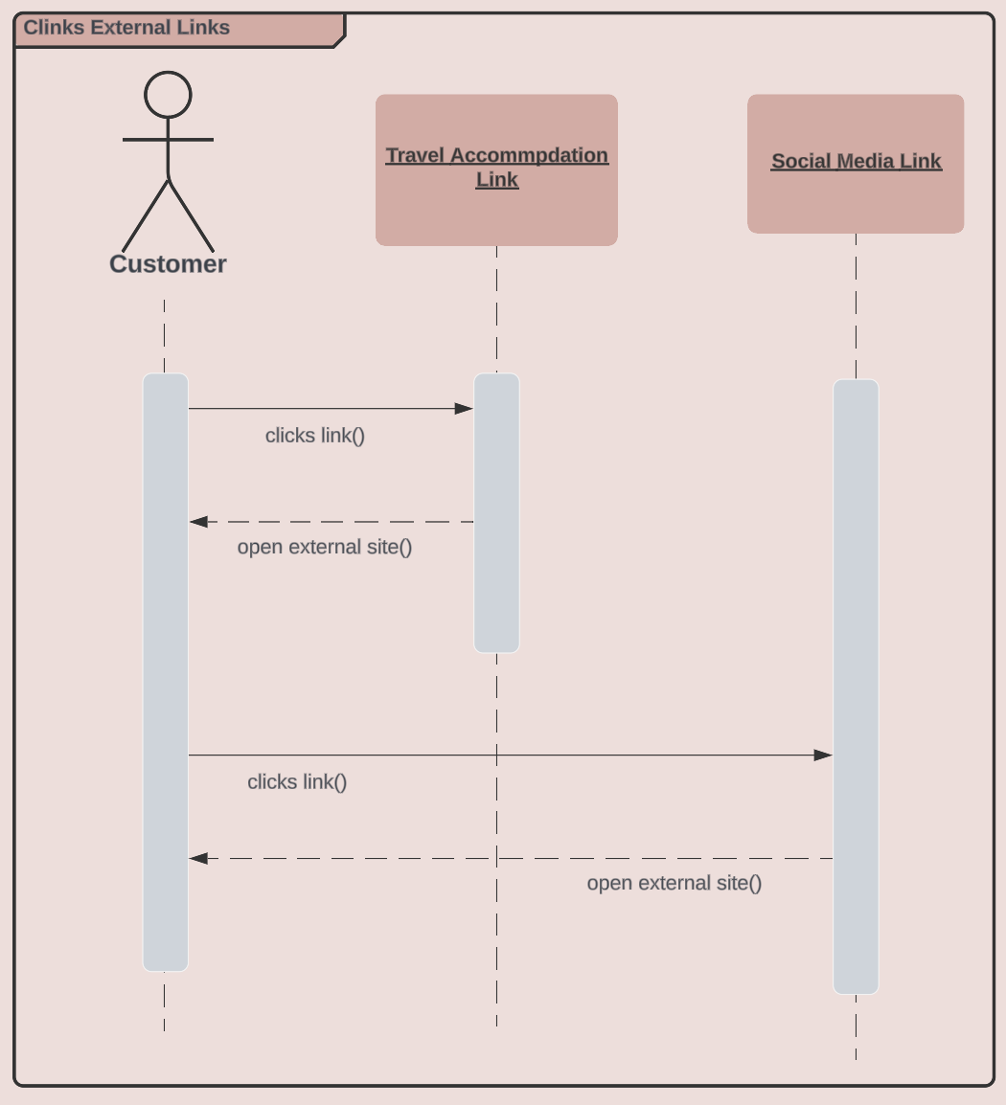

**Use Case Diagrams 11-12: Customer Clicks External Links**

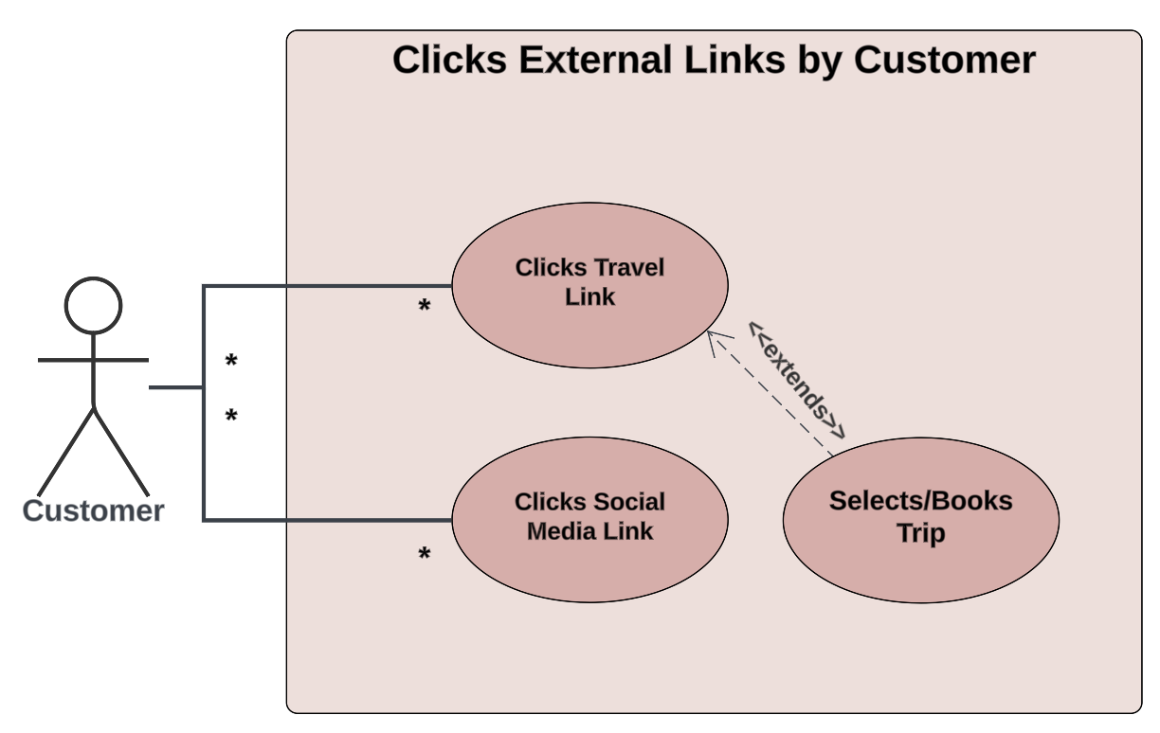

### **Use Case Diagram Narrative**

## On trip details pages, the customer can click external links to travel accommodation sites and guides’ social media. Customers can click many links and each link can be used by many customers. The “Click Travel Accommodation Link” use case extends the “Customer Selects Trip” use case as most customers will only be interested in booking accommodations for trips that they have booked.

**Use Case Description 13: Adds Trips**

|  |  |  |
| --- | --- | --- |
| **Use Case Name**: Adds Trips | **ID**: 13 | **Importance Level**: High |
| **Primary Actor**: GuideBook Employee | | **Use Case Type**: Detail, Essential |
| **Stakeholders and Interests**:   * **Customer:** wants to be able to book new and exciting trips * **Administrator:** wants to ensure that all available trips and listed and their information is accurately entered * **Guide:** wants to ensure that their available trips are able to be booked | | |
| **Brief Description**: This describes how a GuideBook administrator adds a new Pro trip to the GuideBook website. | | |
| **Trigger**: Administrator clicks on “Add a New Trip” on the trip listings page  **Type**: External | | |
| **Relationships**:  Association: Administrator  Include:  Extend:  Generalization: | | |
| **Normal Flow of Events:**   1. Administrator navigates to the trip listings page. 2. Administrator clicks on “Add a New Trip” at the top of this page. 3. A new trip page opens with a template trip details page. 4. The trip details page is in “update mode” and ready for the administrator to input information pertaining to this new trip.    1. Triggers Use Case 15: Administrator Update Pro Trip Details | | |
| **SubFlows:** | | |
| **Alternate/Exceptional Flows:** | | |

**Use Case Description 14: Deletes Trips**

|  |  |  |
| --- | --- | --- |
| **Use Case Name**: Deletes Trips | **ID**: 14 | **Importance Level**: High |
| **Primary Actor**: GuideBook Employee | | **Use Case Type**: Detail, Essential |
| **Stakeholders and Interests**:   * **Customer:** does not want to see trips that are no longer offered * **Administrator:** wants to ensure that trips that are no longer offered are removed * **Guide:** wants to ensure that customers cannot view or book trips that are no longer offered | | |
| **Brief Description**: This describes how a GuideBook administrator deletes a Pro trip from the GuideBook website that is no longer offered. | | |
| **Trigger**: Administrator clicks on “Delete Trip” at the top of a trip detail page.  **Type**: External | | |
| **Relationships**:  Association: Administrator  Include:  Extend: Use Case 13: Administrator Add Pro Trips  Generalization: | | |
| **Normal Flow of Events:**   1. Administrator navigates to a trip details page. 2. Administrator clicks on “Delete Trip” at the top of the page. 3. Warning box asks administrator if they are sure they wish to delete the trip. 4. Administrator clicks “Yes” button and trip is deleted. | | |
| **SubFlows:** | | |
| **Alternate/Exceptional Flows:**  4a. Administrator clicks “No” button and trip is not deleted. | | |

**Use Case Description 15: Updates Trip**

|  |  |  |
| --- | --- | --- |
| **Use Case Name**: Updates Trip | **ID**: 15 | **Importance Level**: High |
| **Primary Actor**: GuideBook Employee | | **Use Case Type**: Detail, Essential |
| **Stakeholders and Interests:**  **Customer: wants trip information to be accurate and reliable**  **Administrator: wants to ensure that trip details are accurate**  **Guide: wants to ensure that trip details are accurate** | | |
| **Brief Description: This describes how a GuideBook administrator updates a Pro trip and its details.** | | |

**Use Case 13-15: Sequence Diagram**

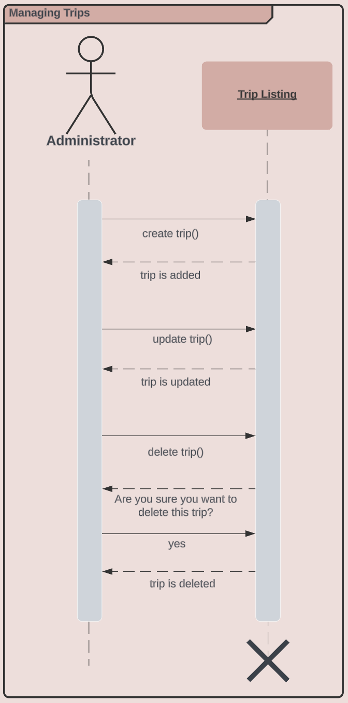

**Use Case Diagrams 13-15: Managing Trips**

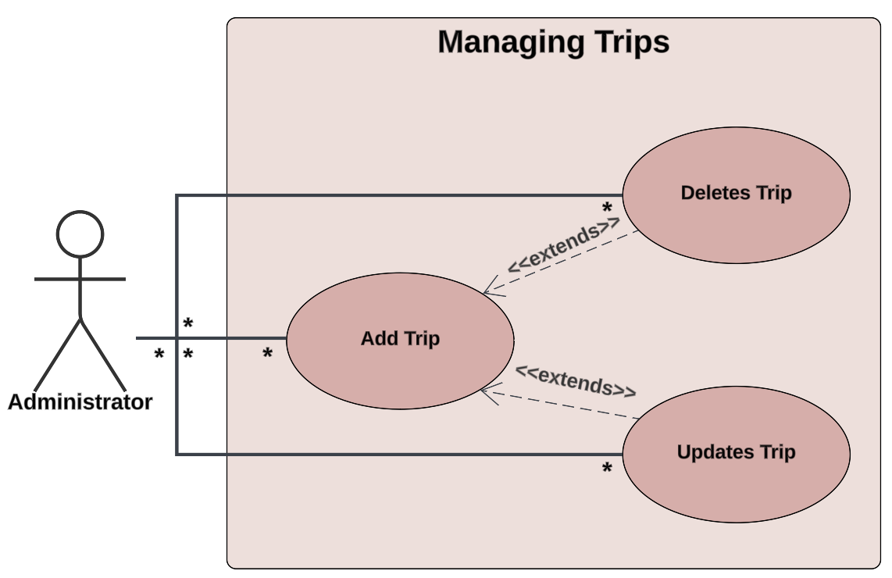

### **Use Case Diagram Narrative**

GuideBook administrators can add, delete, and update Pro trips. They can perform these tasks many times and these tasks can be performed by many administrators. Trips can only be updated and deleted after they have been added.

**Use Case Description 16: Cancels Trip**

|  |  |  |
| --- | --- | --- |
| **Use Case Name**: Cancels Trip | **ID**: 16 | **Risk Level**: Low |
| **Primary Actor**: Administrator | | **Use Case Type**: Detail, Essential |
| **Stakeholders and Interests**:     * ***Administrator:*** Wants to cancel a trip that has been made on behalf of a customer * ***Website:*** This is where the trips will be booked/cancelled | | |
| **Brief Description**: This use case is to create an event where an administrator can cancel a trip that has been booked by a customer | | |
| **Trigger**: The Administrator clicks on “Edit Trip” in the “Booked Trips” tab  **Type**: Essential Overview | | |
| **Relationships**:  *Association:* Administrator  *Include:*  *Extend:* Modify a trip that has already been made in the ‘Booked Trips’ tab  *Generalization:* Editing a trip in the ‘Booked Trips’ tab | | |
| **Normal Flow of Events:**   1. The administrator logs into the website with admin controls 2. The administrator goes to the ‘Customers’ tab 3. The administrator clicks on the profile of needed customer 4. The administrator clicks on the ‘Booked Trips’ tab for that customer 5. The administrator finds the correct trip and selects ‘Edit trip’ 6. The administrator selects ‘Cancel trip’ | | |
| **SubFlows:**   * *None Identified* | | |
| **Alternate/Exceptional Flows:**    1a. Administrator is unable to login due to lack of credentials.  2a. Administrators authentication is rejected and is unable to access website. | | |

**Use Cases 16 & 20: Sequence Diagram**

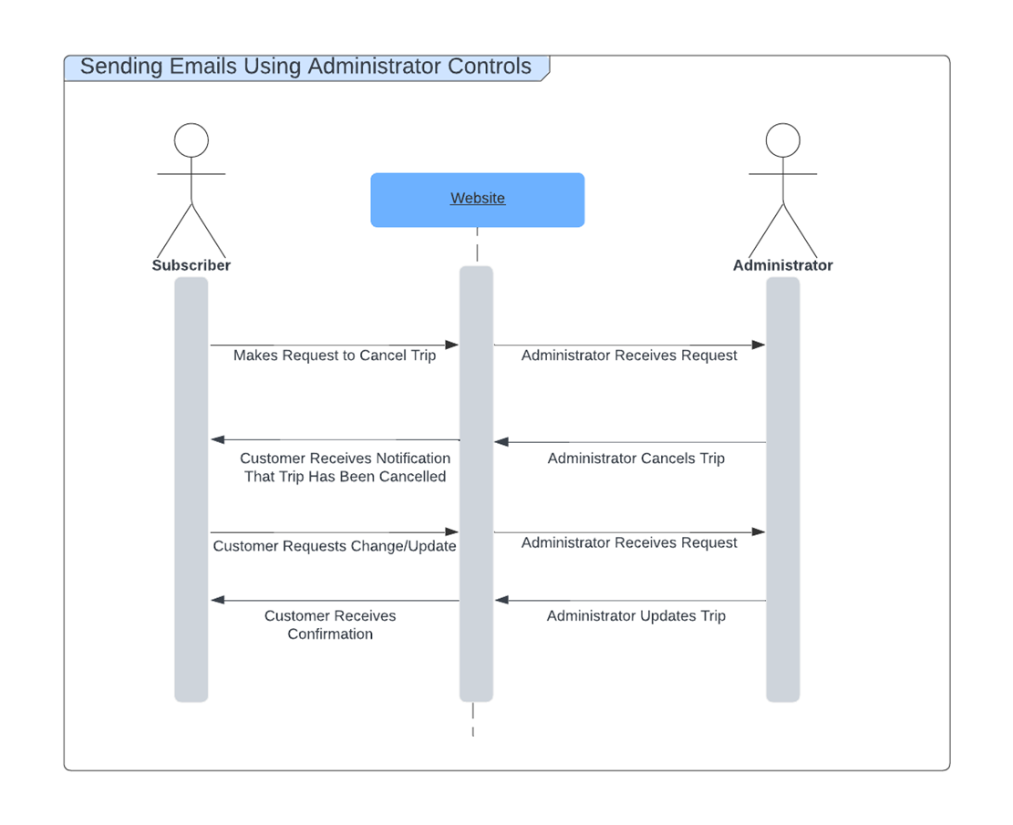

**Use Cases Diagram 16 & 20: Cancelling and Updating Trips**

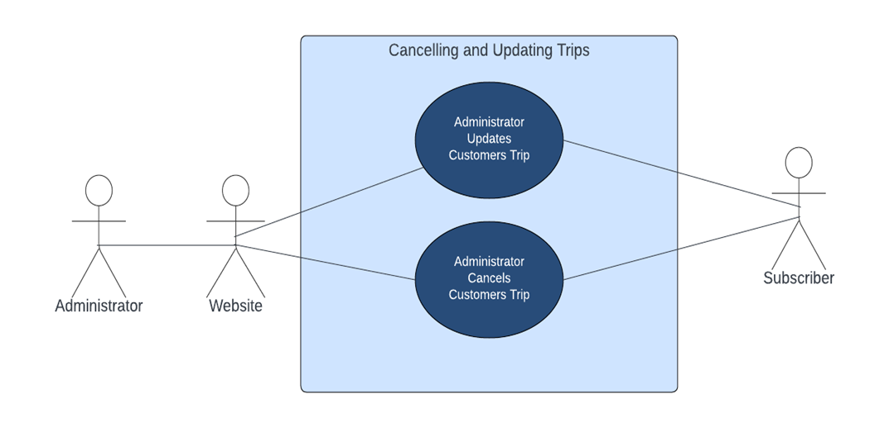

**Use Case Diagram Narrative**

Guidebook Administrators can Update or Cancel the trips for a customer. These tasks can be performed many times and can be performed by any administrator. These Updates will be displayed on the GuideBook Pro page. Any trip that has been cancelled will no longer display on the customers GuideBook Pro page.

**Use Case Description 17: Sends Confirmation Email**

|  |  |  |
| --- | --- | --- |
| **Use Case Name**: Sends Confirmation Email | **ID**: 17 | **Risk Level**: Low |
| **Primary Actor**: Administrator | | **Use Case Type**: Detail, Essential |
| **Stakeholders and Interests**:     * ***Administrator:*** Sends a confirmation email to the customer to ensure that their trip was booked * ***Website:*** Notifies the administrator when a trip is booked | | |
| **Brief Description**: This use case describes how a confirmation email will be sent to the customer upon booking a trip | | |
| **Trigger**: Customer books a trip through GuideBook Pro and a notification is sent to the Administrator  **Type**: Essential Overview | | |
| **Relationships**:  *Association:* Administrator and Customer  *Include:* Create a confirmation email for the customer  *Extend:* Customize the confirmation email for the customer  *Generalization:* Confirmation email is sent to customer | | |
| **Normal Flow of Events:**   1. The administrator logs into the website with admin controls 2. The administrator receives a notification of a booked trip 3. The administrator pulls up the template for confirmation emails 4. The administrator customizes the email for this particular trip and customer 5. The administrator sends the email to the customer to confirm that their trip has been booked | | |
| **SubFlows:**   * *None Identified* | | |
| **Alternate/Exceptional Flows:**    1a. Administrator is unable to login due to lack of credentials.  2a. Administrator is unable to send the email due to invalid information  3a. Customer does not receive email due to invalid information | | |

**Use Case Description 18: Sends Yearly Review Email**

|  |  |  |
| --- | --- | --- |
| **Use Case Name**: Sends Yearly Review Email | **ID**: 18 | **Importance Level**: Low |
| **Primary Actor**: Administrator | | **Use Case Type**: Detail, Essential |
| **Stakeholders and Interests**:     * ***Administrator:*** Sends a yearly review email to all GuideBook Pro members * ***Website:*** This is where most of the information for the email will be collected from | | |
| **Brief Description**: This use case describes how an Administrator will | | |
| **Trigger**: The year comes to an end and the GuideBook Pro team decides when to send the email  **Type**: Essential Overview | | |
| **Relationships**:  *Association: Administrator and Subscribers*  *Include:* Create a summary email of all the most interesting trips and events provided by GuideBook Pro  *Extend:*  *Generalization:* A yearly review email is sent to all subscribers | | |
| **Normal Flow of Events:**   1. The administrator logs into the website with admin controls 2. The administrator compiles all of the information needed for the yearly review email 3. The administrator creates the email 4. The administrator sends the email to all subscribers of Guide Book Pro | | |
| **SubFlows:**   * *None Identified* | | |
| **Alternate/Exceptional Flows:**    1a. Administrator is unable to login due to lack of credentials.  2a. Administrator is unable to send the email due to invalid information  3a. Customer does not receive email due to invalid information | | |

**Use Cases 17-18: Sequence Diagram**

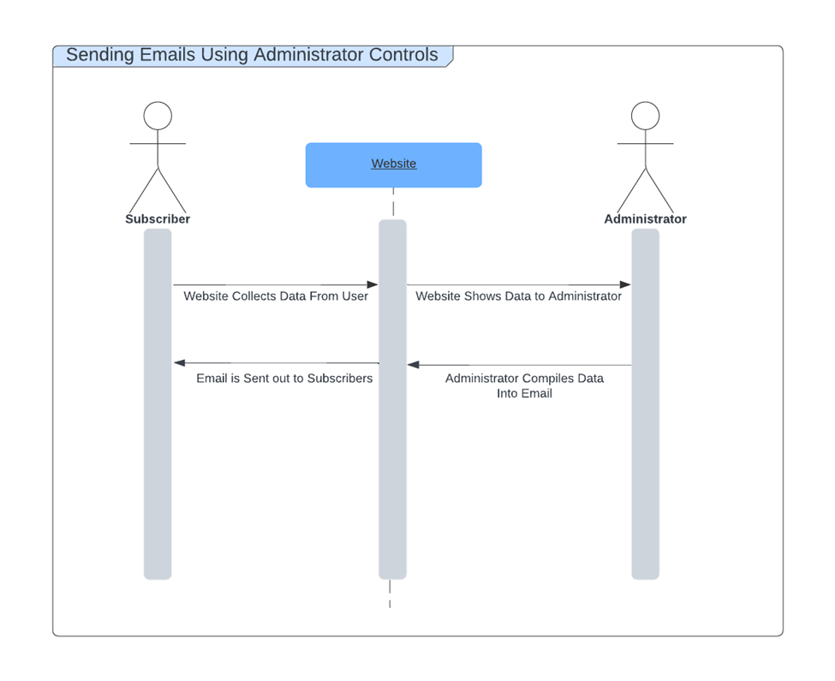

**Use Cases Diagram 17-18: 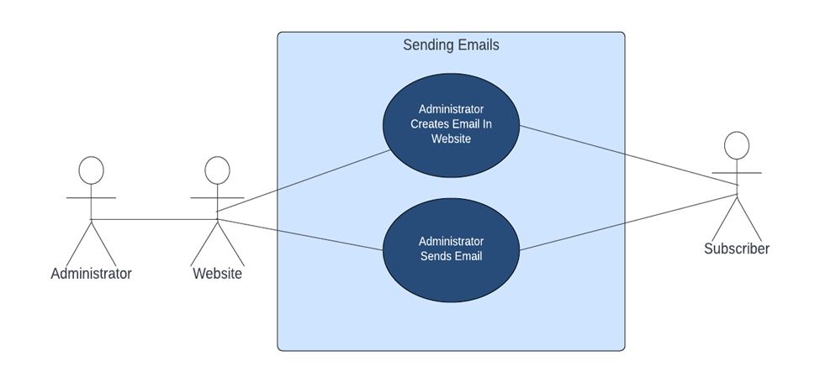Use Case Diagram Narrative**

Guidebook Administrators have the ability to send emails to the subscribers of GuideBook Pro. These emails are either a trip confirmation or a yearly review email. Administrators create the email inside of the website and then send the email to the customers. Any administrator can create an email. Any administrator can also send an email.

**Use Case Description 19: Responds to Customers**

|  |  |  |
| --- | --- | --- |
| **Use Case Name**: Responds to Customers | **ID**: 16 | **Risk Level**: High |
| **Primary Actor**: Administrator | | **Use Case Type**: Detail, Essential |
| **Stakeholders and Interests**:     * ***Administrator:*** Responds to Customers questions/concerns * ***Website:*** This is where the Questions and concerns will be asked * ***Customer:*** Has a question or concern that needs to be addressed | | |
| **Brief Description**: This use case is to create an event where an administrator can cancel a trip that has been booked by a customer | | |
| **Trigger**: The Administrator clicks on “Edit Trip” in the “Booked Trips” tab  **Type**: Essential Overview | | |
| **Relationships**:  *Association:* Administrator  *Include:*  *Extend:* Modify a trip that has already been made in the ‘Booked Trips’ tab  *Generalization:* Editing a trip in the ‘Booked Trips’ tab | | |
| **Normal Flow of Events:**   1. The administrator logs into the website with admin controls 2. The administrator clicks on the profile of needed customer 3. The administrator clicks on the ‘Message’ tab for that customer 4. The administrator types out a message to respond to the customer | | |
| **SubFlows:**   * *None Identified* | | |
| **Alternate/Exceptional Flows:**    1a. Administrator is unable to login due to lack of credentials.  2a. Administrators authentication is rejected and is unable to access website.  3a. Administrators message does not go through due to invalid connection  4a. Customer does not receive response due to invalid connection | | |

**Use Case 19: Sequence Diagram**

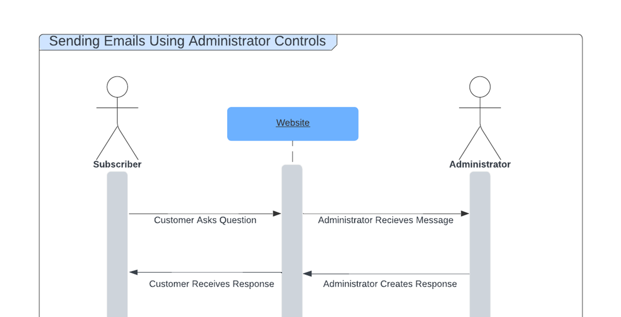

**Use Case Diagram 19: Responding to Customers**

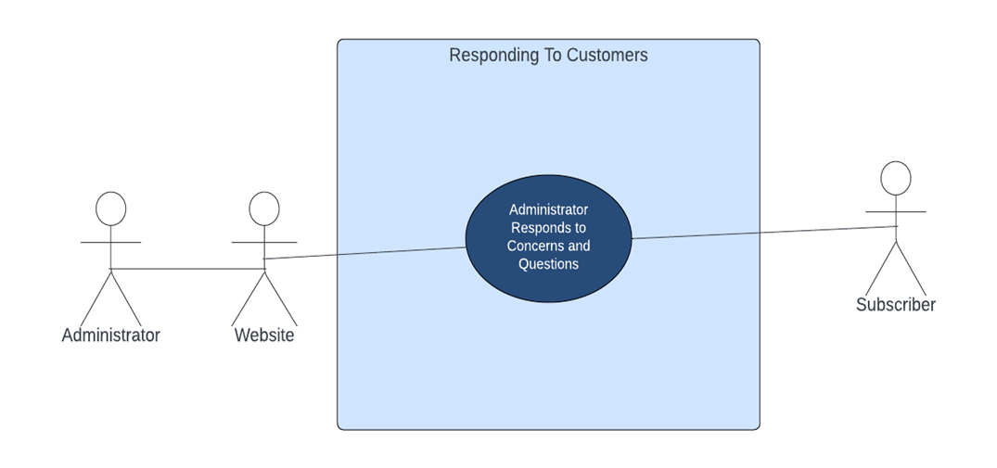

**Use Case Diagram Narrative**

GuideBook administrators have the ability to respond to concerns and questions of customers through a forum on the website. Any administrator can respond to these concerns and questions but only one can be in the “chat room” of that customer at a time. Any subscriber can ask questions or address concerns through the forum.

**Use Case Description 20: Updates Booking**

|  |  |  |
| --- | --- | --- |
| **Use Case Name**: Updates Booking | **ID**: 20 | **Risk Level**: High |
| **Primary Actor**: Administrator | | **Use Case Type**: Detail, Essential |
| **Stakeholders and Interests**:     * ***Administrator:*** Wants to Update a trip that has been made on behalf of a customer * ***Website:*** This is where the trip will be updated | | |
| **Brief Description**: This use case is to create an event where an administrator can update a trip that has been booked by a customer | | |
| **Trigger**: The Administrator clicks on “Edit Trip” in the “Booked Trips” tab  **Type**: Essential Overview | | |
| **Relationships**:  *Association:* Administrator  *Include:*  *Extend:* Modify a trip that has already been made in the ‘Booked Trips’ tab  *Generalization:* Editing a trip in the ‘Booked Trips’ tab | | |
| **Normal Flow of Events:**   1. The administrator logs into the website with admin controls 2. The administrator goes to the ‘Customers’ tab 3. The administrator clicks on the profile of needed customer 4. The administrator clicks on the ‘Booked Trips’ tab for that customer 5. The administrator finds the correct trip and selects ‘Edit trip’ 6. The administrator selects ‘Update trip’ | | |
| **SubFlows:**   * *None Identified* | | |
| **Alternate/Exceptional Flows:**    1a. Administrator is unable to login due to lack of credentials.  2a. Administrators authentication is rejected and is unable to access website. | | |

**Use Case Description 21: Messages Client**

|  |  |  |
| --- | --- | --- |
| **Use Case Name:** Messages Client | ID: 21 | **Importance Level:** Low |
| **Primary Actor:** Guide | | **Use Case Type:** Detail, Essential |
| **Stakeholders and Interests:**  ·  **Guide**- Wants to communicate with customers to inform them about the confirmation of their trip booking and give them a warm welcome.  · **Guidebook Pro clients**- Appreciates the personalized communication from the guide that they have booked with.  · **Guidebook Owners**- Aim to provide a valuable piece of customer service for their Guidebook Pro subscribers from their professional fishing guides. | | |
| **Brief Description:** This use case describes the process that a guide will take to reach out to Guidebook Pro subscribers privately once they have booked a trip. This message will include a simple note such as “you’re all set, looking forward to our fishing trip” as an example. This use case is meant to increase client satisfaction while also keeping them informed that their booking is secured. | | |
| **Trigger:** Guidebook Pro client/user finishes the booking process of a fishing guide  Type: External | | |
| **Relationships:**  Association: Guide & Guidebook Pro client  Include: Client booking a trip  Extend: N/A  Generalization: Communication between guide and client | | |
| **Normal Flow of Events:**  1. Client Books a Fishing Trip:  - A Guidebook Pro client completes the booking process through the Guidebook Pro’s online booking system.    2. Trip Booking Confirmation:  - The booking system automatically confirms the trip booking to the client via email.    3. Guide Assignment Notification:  - The system then notifies the guide of the new trip booking, providing them with necessary details such as the customer's name and email  address.    4. Guide Prepares the Message:  - The guide logs into the system to access the client's email address and prepares a personalized message for the customer.    5. Sending the Message:  - Using the client’s email address from the system, the guide sends a personalized message directly to the client.    6. Client Receives the Message:  - The client receives the guide's message, enhancing their anticipation for the trip and feeling more connected to the guide and the service provided by the company. | | |
| **SubFlows: None** | | |  |
| **Alternate/Exceptional Flows:**    1. Guide unable to login:  · Guide attempts login but fails due to incorrect credentials.  · System offers password reset or contact support.  · Guide resets password or contacts support, then proceeds.    2. Authentication rejected:  · Guide's credentials for authentication fails.  · System displays error and suggests checking credentials or resetting password.  · Guide resolves the issue based on suggestions and retries.    3. Invalid email:  · Guide's email fails validation due to unsupported characters, attachments, or email length.  · The Guidebook Pro system tells the specific issue with the content of the email.  · Guide modifies the contents of the message to meet system requirements.  Guide sends the welcome message via Guidebook Pro guide messaging feature. | | |  |

**Use Case 21: Sequence Diagram**

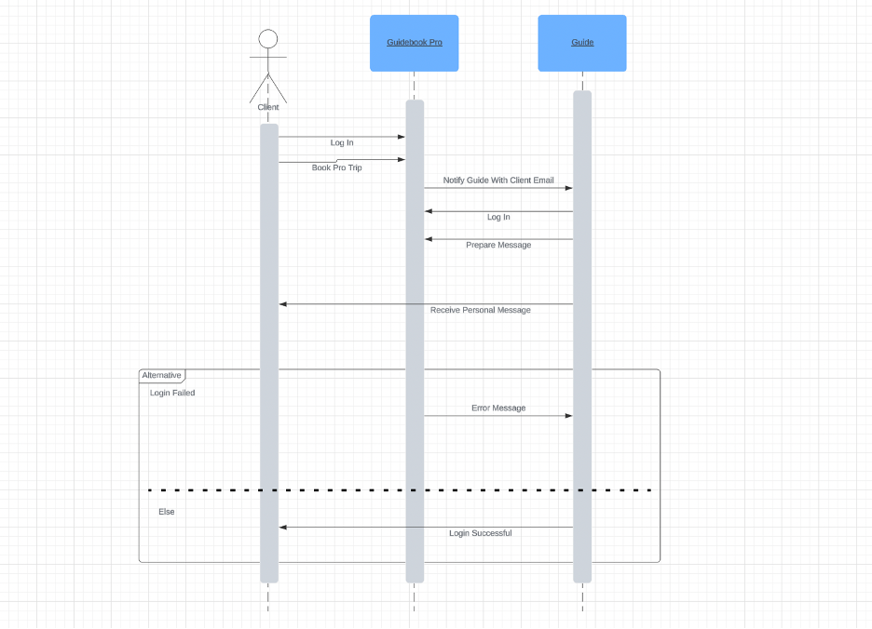

**Use Case Diagram 21: Messages Client**

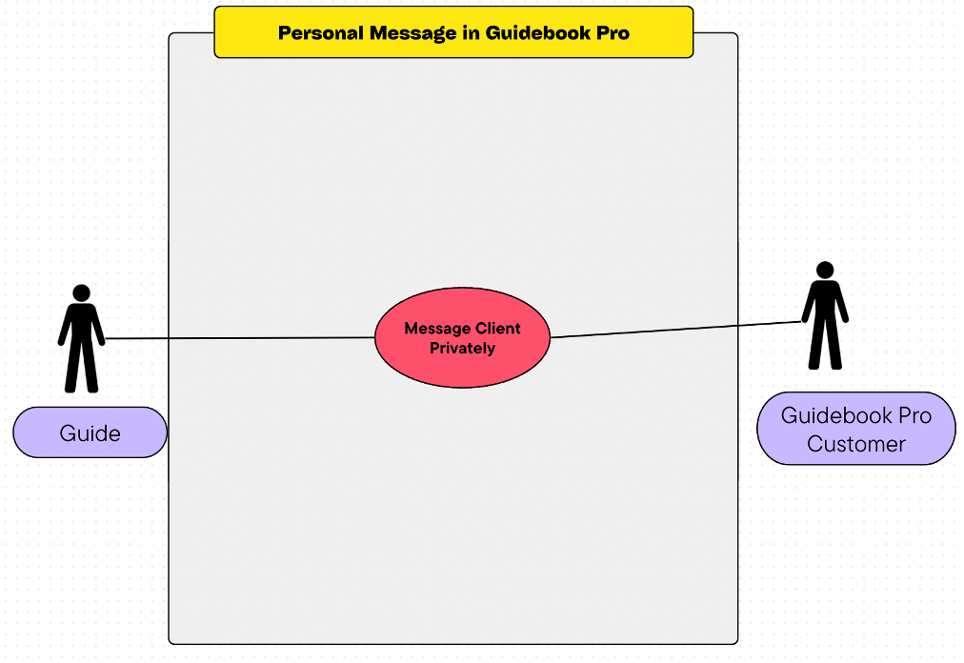**Use Case 21 Diagram Narrative:**

After a Guidebook Pro customer has booked a trip successfully, the guide can message them privately in a welcoming and informative manner. The guide will send their welcome message from the Guidebook Pro platform. The Guidebook Pro customer will then receive the personal message from the guide. This diagram fulfills the need of guides sending a message privately to a Guidebook Pro customer.

**Use Case Description 22: Accesses Pro Via Link**

|  |  |  |
| --- | --- | --- |
| **Use Case Name**:  Accesses Pro Via Link | **ID**: 22 | **Importance Level**: Low |
| **Primary Actor**: Customer | | **Use Case Type**: Detail, Essential |
| **Stakeholders and Interests**:     * **Guidebook Pro Subscribers-** Wants direct, secure access to the Guidebook Pro platform to manage their bookings and access exclusive content. * **Guidebook Pro Guides-** Wants an easily accessible platform that allows subscribers to book trips regularly. * **Guidebook Owners-** Wants to improve user experience for premium clients by providing direct access to their exclusive platform, making their platform easy to find for Guidebook Pro customers. | | |
| **Brief Description**: This use case describes the process of a Guidebook Pro subscriber accessing the platform by clicking a link directly to the Guidebook Pro page. This link will be included in an email or even an external website such as a blog or news article. | | |
| **Trigger**: Guidebook Pro customer clicks a Guidebook Pro link  **Type**: External | | |
| **Relationships**:  *Association:* Guidebook Pro subscriber & Guidebook Pro platform  *Include: Subscriber login*  *Extend: N/A*  *Generalization:* Guidebook Pro platform access | | |
| **Normal Flow of Events:**  **1.** **Customer Receives or Finds the Link:**  -A Guidebook Pro customer receives the link via email or finds the link on an external website.    **2.** **Customer Clicks on Link:**  -The customer clicks on the link to access the Guidebook Pro platform.    **3.** **Link Verification and Access:**  -The customer is transitioned to the platform  -The customer will have to log in with their credentials or register an account if applicable.    **4.** **Welcome and Orientation:**   * Upon successful registration, the new subscriber gains full access to the platform and is welcomed with orientation resources.     **5.** **Platform Engagement:**  -The subscriber engages with the platform, accessing bookings, guides, and exclusive content. | | |
| **SubFlows: None** | | |  |
| **Alternate/Exceptional Flows:**    **1. Invalid or Expired Link:**   * Subscriber clicks a link that is invalid or expired. * The system displays a message indicating the issue and provides instructions to get a new link or how to contact customer support.   **2. Authentication Challenges:**   * During the registration process, the customer encounters challenges such as input errors or missing information. * The system provides feedback and guidance to complete the registration successfully.   **3. Technical Issues:**   * The customer encounters technical difficulties accessing the platform via the link. * The system offers troubleshooting advice and contact information for the customer service support line. * The customer follows the advice or contacts support to resolve the access issue. | | |  |

**Use Case Description 23: Clicks Pro Tab**

|  |  |  |
| --- | --- | --- |
| **Use Case Name**:  Clicks Pro Tab | **ID**: 23 | **Importance Level**: Low |
| **Primary Actor**: Customer | | **Use Case Type**: Detail, Essential |
| **Stakeholders and Interests**:    · **Customer:** Interested in exploring and possibly upgrading to the Guidebook Pro platform for a more exclusive service.  · **Guides:** Want the benefit from an increase of customer exposure and potential increase of future subscribers that will book guided trips.  · **Guidebook Owners:** Want to provide a smooth transition for customers to become Guidebook Pro subscribers in the future, increasing future platform growth. | | |
| **Brief Description**: This use case describes the process that a customer will take on the base Guidebook website to reach Guidebook Pro. The customer will be able to click a tab in the Guidebook website that will directly transition them into Guidebook Pro. | | |
| **Trigger**: Customer clicks the Guidebook Pro tab in the Guidebook website  **Type**: External | | |
| **Relationships**:  *Association:* Customer & Guidebook Pro tab  *Include: Accessing Guidebook Pro*  *Extend: N/A*  *Generalization:* Navigation of website | | |
| **Normal Flow of Events:**  **1.** **Exploring Guidebook Website:**  - A customer browses the Guidebook base website, looking for information or managing their existing Guidebook bookings.    **2.** **Interest in Guidebook Pro:**  - The customer notices and becomes interested in the Guidebook Pro tab on the website, presenting an exclusive and premium service offering.    **3.** **Clicking Guidebook Pro Tab:**  - The customer clicks on the Guidebook Pro tab to learn more about the service.    **4.** **Redirected to Login Page:**  - The system redirects the customer to the Guidebook Pro login/invitation page, the same endpoint as in Use Case 22, informing them about the invite-only nature of the platform and how to express interest or seek an invitation to Guidebook Pro. | | |
| **SubFlows: None** | | |  |
| **Alternate/Exceptional Flows:**    **1. Page Load Error:**   * The customer encounters a loading error or technical issue when trying to access the Guidebook Pro tab. * The system provides error messages and troubleshooting suggestions.   **2. Seeking Invitation:**   * The customer is interested in obtaining an invitation to Guidebook Pro but is unsure how to proceed from the login/invitation page. * The system offers information on how traditional customers can express interest in receiving an invitation.   **3. Returning to Base Website:**   * The customer decides not to pursue Guidebook Pro at this time and wants to return to the base website. * The customer clicks on the tab to return back to the Guidebook base website. | | |  |

**Use Case 22 & 23: Sequence Diagram**

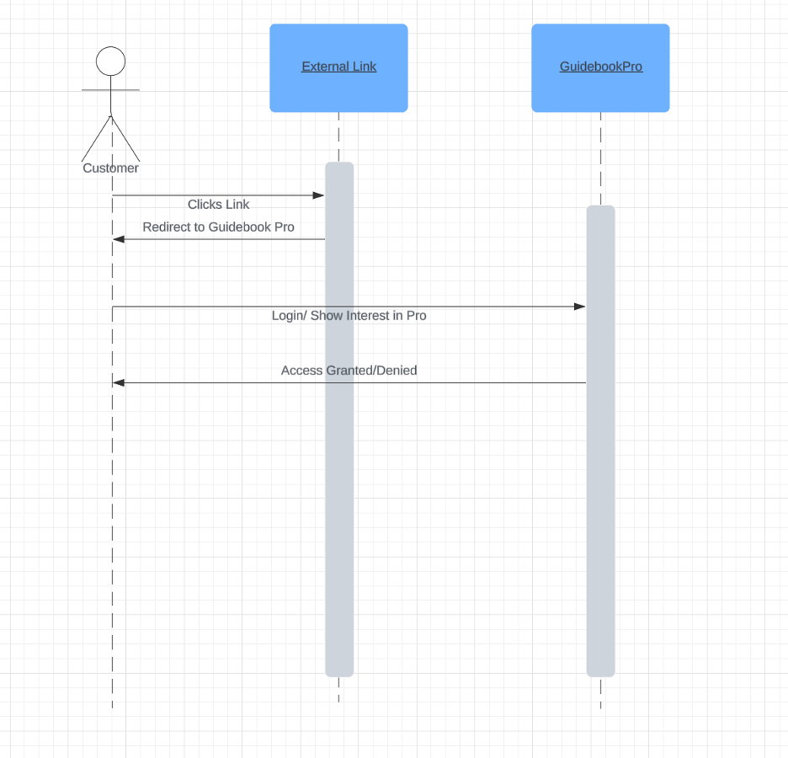

**Use Case Diagram 22 & 23: Accessing Guidebook Pro**

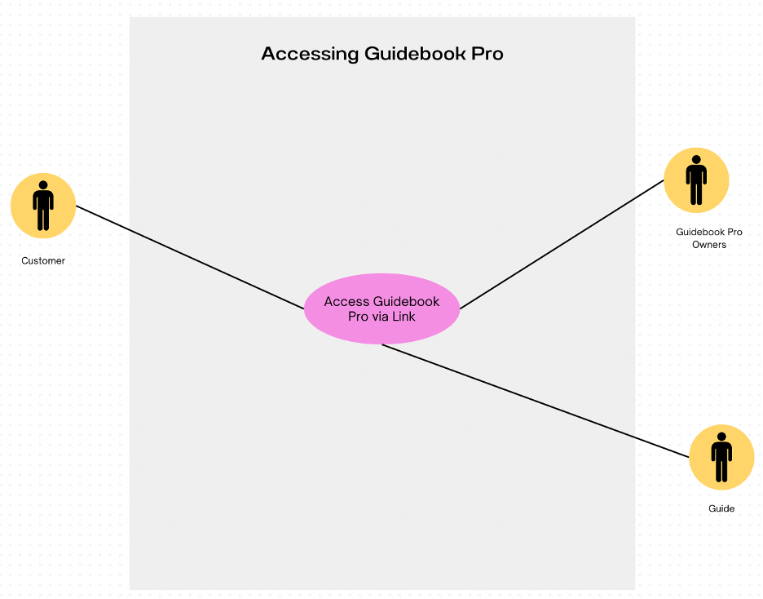

**Use Case 22 & 23 Diagram Narrative:**

When accessing the Guidebook Pro platform from a link or Guidebook Pro tab, every actor involved (customer, Guidebook Pro owners, guides) will click on the feature and be directed to Guidebook Pro information and log in within the Guidebook website. Any actor will only be able to gain access to Guidebook Pro content and interface with their set permissions if they provide the proper credentials.

**Use Case Description 24: Creates Guide Account**

|  |  |  |
| --- | --- | --- |
| **Use Case Name**:  Creates Guide Account | **ID**: 24 | **Importance Level**: High |
| **Primary Actor**: Guide | | **Use Case Type**: Detail, Essential |
| **Stakeholders and Interests**:    · Guide- Interested in starting their Guidebook Pro experience to optimize their fish guide business.   * Guidebook Owners- Aim to provide an experience that expert fishing guides seek to join to enhance the value of Guidebook Pro. * Guidebook Pro Subscribers- Benefit from Guidebook owners ensuring that all guides are verified and qualified to provide quality experiences. | | |
| **Brief Description**: This use case describes the process of guide setting up their Guidebook Pro account. The guide will need to include their personal information, their fishing licenses/certifications, and their social media for Guidebook Pro to consider adding them to the team. | | |
| **Trigger**: Guide decides to join Guidebook Pro.  **Type**: Internal | | |
| **Relationships**:  *Association:* Guide & Guidebook Pro  *Include: Setting up Account*  *Extend: N/A*  *Generalization:* Account Creation | | |
| **Normal Flow of Events:**  **1.** **Guide Accesses Signup Page**  - The guide navigates to the Guidebook Pro signup page.    **2.** **Guide Submits Information for Verification**  - The guide fills out the registration form, including personal and professional details.    **3.** **Account Creation**  - The Guidebook owner verifies the guides qualifications.  - The Guidebook owner then accepts or rejects the guide creating the account.  - The system sends a confirmation email to the guide.    **4.** **Guide Sets Up Profile**  - The guide completes their profile setup by adding credentials, experience, and date availability for Guidebook Pro customers to view.    **5.** **Guidebook Pro Owners Verify Profile**  - The Guidebook Pro owners will do a final check to ensure that the guides’ profile is accurate and matches their profile requirements.  - Guidebook Pro owners decide whether to make the profile public to start accepting clients or not. | | |
| **SubFlows: None** | | |  |
| **Alternate/Exceptional Flows:**    **Invalid or Missing Information**   * Guide submits incomplete or missing information on their account creation. * The guide is notified of any adjustments that need to be made     **2. Verification Failure**  **-** Owners conclude that the guide has insufficient information or qualifications to become a guide.  - Guide is notified of whether they were accepted or rejected from continuing the process of becoming a guide.     * + - 1. **Technical Error Creating Account** * The system doesn’t process the account creation properly. * The guide contacts the Guidebook Pro owner or customer service. * A Guidebook Pro representative takes care of the technical issue.     **4. Final Guide Account Doesn’t Align with Expectations**  - Guidebook Pro owners examine the guides’ profile and determines it isn’t suitable to begin accepting clients.  -The guide is notified of the changes that should be made to their account. | | |  |

**Use Case Description 25: Update Guide Account**

|  |  |  |
| --- | --- | --- |
| **Use Case Name**:  Update Guide Account | **ID**: 25 | **Importance Level**: Medium |
| **Primary Actor**: Guide | | **Use Case Type**: Detail, Essential |
| **Stakeholders and Interests**:    · Guides- Interested in keeping their account information up to date to accurately reflect their services, availability, and qualifications to customers.    · Guidebook Pro Subscribers- Benefit from accurate and current information about the guides to choose who suits their needs for a valuable experience.    · Guidebook Owners- Want to ensure all guide profiles are accurate and provide value to subscribers, who pay the premium price. | | |
| **Brief Description**: This use case details the process of a guide being able to update their information on their Guidebook Pro account. Guidebook Pro subscribers can see up to date and detailed information on each guide, and Guidebook Pro owners will be able to keep their platform’s information as current as possible. | | |
| **Trigger**: Guide decides to update the information on their Guidebook Pro profile  **Type**: Internal | | |
| **Relationships**:  *Association:* Guide & Guidebook Pro  *Include: N/A*  *Extend: N/A*  *Generalization:* N/A | | |
| **Normal Flow of Events:**  **1.** **Guide Logs In:**  - The guide logs into their account using their personal credentials    **2.** **Navigates to Account Settings:**  - The guide navigates to the account settings on Guidebook Pro.    3. **Guide Updates Information**:  - The guide updates their information such as personal, contact, new credentials, etc. to suggest adding to their profile.    2. **Guide Submits Updates**:  - The guide submits the new information for processing.    2. **System Confirm Changes**:  - The system processes the guides’ changes and notifies Guidebook Pro owners.    **3.** **Owners Confirm Changes:**  - The owners will review the changes after they have been made and will make any necessary overrides or proposed revisions. | | |
| **SubFlows: None** | | |  |
| **Alternate/Exceptional Flows:**    1. Login Issues:  - Guide encounters issues logging in.  - The system provides options for password recovery or support contact.  2. Invalid Information Submitted:  - The guide submits information that fails validation checks (incorrect format or unsupported characters).  - The system notifies the guide of the specific errors, and the guide corrects the information before resubmitting.  3. Technical Difficulties During Update:  - Guide experiences technical difficulties while updating information system timeout or errors).  - The system offers troubleshooting advice or an option to contact support. The guide attempts the update again after resolving the issue.  4. Review Required for Certain Updates:  - Updates to certain sensitive or critical information require additional review by GuideBook Pro owners.  - The guide submits the update, which is flagged for review. The guide is informed of the review process and timeline. | | |  |

**Use Cases 24 & 25: Sequence Diagram**

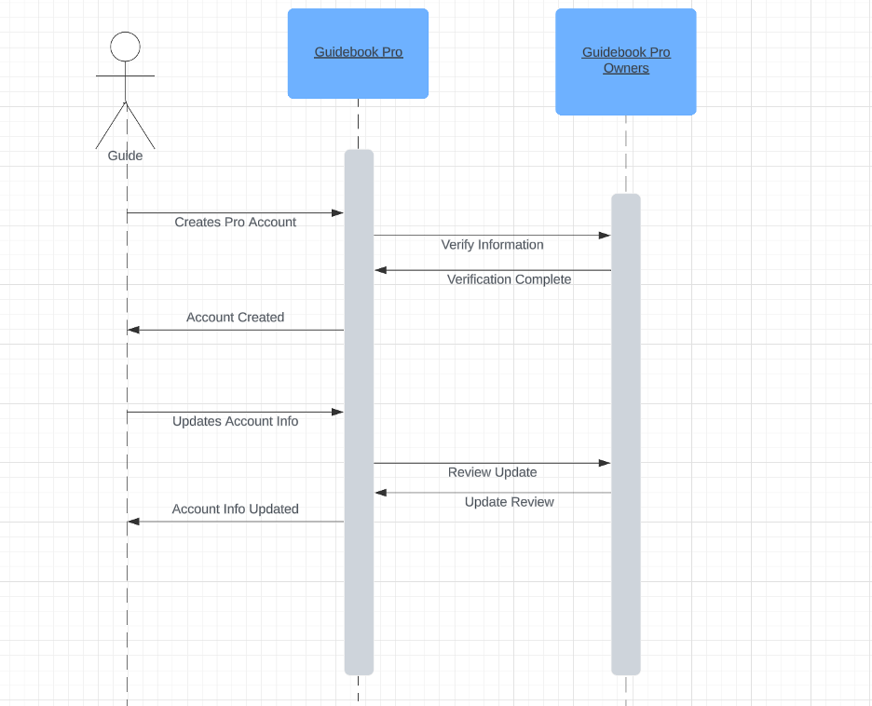

**Use Cases Diagram 24 & 25: Managing the Guide Account**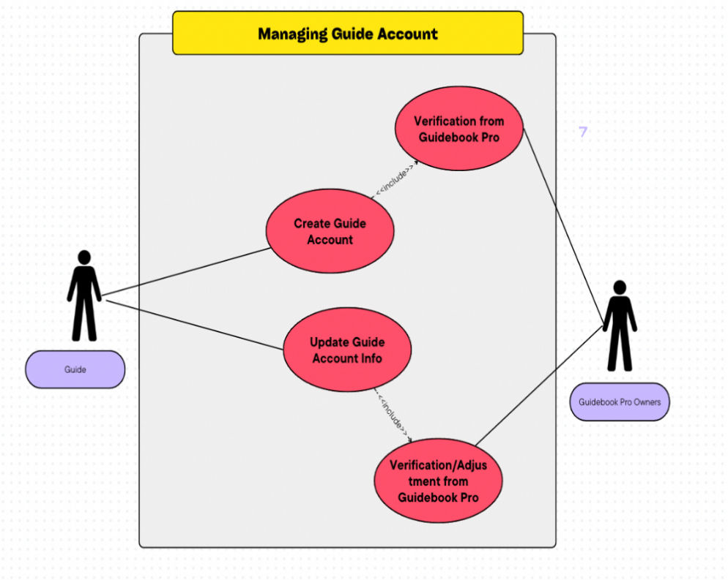

**Use Case 24 & 25 Diagram Narrative:**

Managing a guide’s account will include the guide and Guidebook Pro owners. This use case diagram involves creating the guide’s account and updating the guide’s information contained in the account. Once the guide has been invited to join Guidebook Pro, the guide will be able to create an account. Once created, the account will include the needed verification from Guidebook Pro owners to ensure that the information meets their requirements. If the information needs adjustment and/or clarification, the Guidebook Pro owners will relay this to the guide. When updating guide account information, the guide will navigate to their account in Guidebook Pro to edit their information. Once the guide has updated their information, the Guidebook Pro owners will again verify the information and make any needed adjustments to ensure the information is suitable for the platform.

**Use Case Description 26: Deletes Guide Account**

|  |  |  |  |
| --- | --- | --- | --- |
| **Use Case Name**: Deletes Guide Account | | **ID**: 26 | **Importance Level**: High |
| **Primary Actor**: Guide User | **Use Case Type**: Detail, Essential | | |
| **Stakeholders & Interests**:   * **Guide**: Wants to delete own account for personal reasons, i.e. leaving * **Administrator**: Wants to delete account of banned/terminated guide(s) | | | |
| **Brief Description**: This use case details how a guide account is deleted, removing the account from the system. | | | |
| **Trigger**: User clicks on the “Delete Account” button in profile settings    **Type**: External | | | |
| **Relationships**:   * **Association**: Guide, Administrator * **Include**: Ban/Terminate Guide * **Extend**: ID 28: Delete Customer Account * **Generalization**: Account Management in Profile Settings Tab | | | |
| **Normal Flow of Events**:   1. The Guide logs into their GuideBook Pro account    1. If enabled, the guide verifies their identity via two-factor authentication 2. The guide clicks their profile icon on the top-right of the website 3. The guide chooses “Account Setting” under their profile icon 4. The guide chooses “Manage Account” under the Account Settings webpage 5. The guide chooses “Delete Account” under the Manage Account tab 6. The guide confirms they wish to delete their account 7. The system will then remove the information of the guide from the database    1. If a Pro member, cancels the subscription by the end of the payment session    2. As a Guide, this also removes their bank information from the system | | | |
| **Sub-Flows**: None | | | |
| **Alternate/Exceptional Flows**:   1. The administrator enters the guide’s profile in a similar manner, deleting the account the same way. 2. The guide is unable to authenticate their identity and/or log in 3. The guide, upon confirming they wish to delete their account, cancels- taking them back to the profile settings | | | |

**Use Case Description 27: Guide Inputs Bank Info**

|  |  |  |  |
| --- | --- | --- | --- |
| **Use Case Name**: Guide Inputs Bank Info | | **ID**: 27 | **Importance Level**: High |
| **Primary Actor**: Guide user | **Use Case Type**: Detail, Essential | | |
| **Stakeholders & Interests**:   * **Guide**: Wants to include their bank information to get paid * **Administrator**: Wants to management payments to guides for their trips | | | |
| **Brief Description**: This use case details how a guide can insert their bank information into their GuideBook profile to receives payments for trips they held | | | |
| **Trigger**: Users clicks on the “Link Bank Account” button in profile settings    **Type**: External | | | |
| **Relationships**:   * **Association**: Guide, Bank * **Include**: * **Extend**:   + Customer Adds Payment Information   + Customer Updates Payment Information * **Generalization**: Account Management in Profile Settings Tab | | | |
| **Normal Flow of Events**:   1. The Guide logs into their GuideBook Pro account    1. If enabled, the guide verifies their identity via two-factor authentication 2. The guide clicks their profile icon on the top-right of the website 3. The guide chooses “Account Setting” under their profile icon 4. The guide chooses “Manage Account” under the Account Settings webpage 5. The guide chooses “Payment” under the Manage Account tab 6. The guide enters their bank name and number to link to their account | | | |
| **Sub-Flows**: None | | | |
| **Alternate/Exceptional Flows**: None | | | |

**Use Case Description 28: Customer Deletes Account**

|  |  |  |  |
| --- | --- | --- | --- |
| **Use Case Name**: Customer Deletes Account | | **ID**: 28 | **Importance Level**: High |
| **Primary Actor**: Customer | **Use Case Type**: Detail, Essential | | |
| **Stakeholders & Interests**:   * Customer: Wants to delete own account for personal reasons, i.e. leaving * Administrator: Wants to delete account of banned/terminated customer(s) | | | |
| **Brief Description**: This use case details how a customer account is deleted, removing the account from the system. | | | |
| **Trigger**: User clicks on the “Delete Account” button in profile settings    **Type**: External | | | |
| **Relationships**:   * **Association**: Customer, Administrator * **Extend**: Ban/Terminate Customer * **Include**: ID 26: Delete Guide Account * **Generalization**: Account Management in Profile Settings Tab | | | |
| **Normal Flow of Events**:   1. The customer logs into their GuideBook Pro account    1. If enabled, the customer verifies their identity via two-factor authentication 2. The customer clicks their profile icon on the top-right of the website 3. The customer chooses “Account Setting” under their profile icon 4. The customer chooses “Manage Account” under the Account Settings webpage 5. The customer chooses “Delete Account” under the Manage Account tab 6. The customer confirms they wish to delete their account 7. The system will then remove the information of the customer from the database    1. If a Pro member, cancels the subscription by the end of the payment session | | | |
| **Sub-Flows**: None | | | |
| **Alternate/Exceptional Flows**:   1. The administrator enters the customer’s profile in a similar manner, deleting the account the same way. 2. The customer is unable to authenticate their identity and/or log in 3. The customer, upon confirming they wish to delete their account, cancels- taking them back to the profile settings | | | |

**Use Cases 26-28: Sequence Diagram**

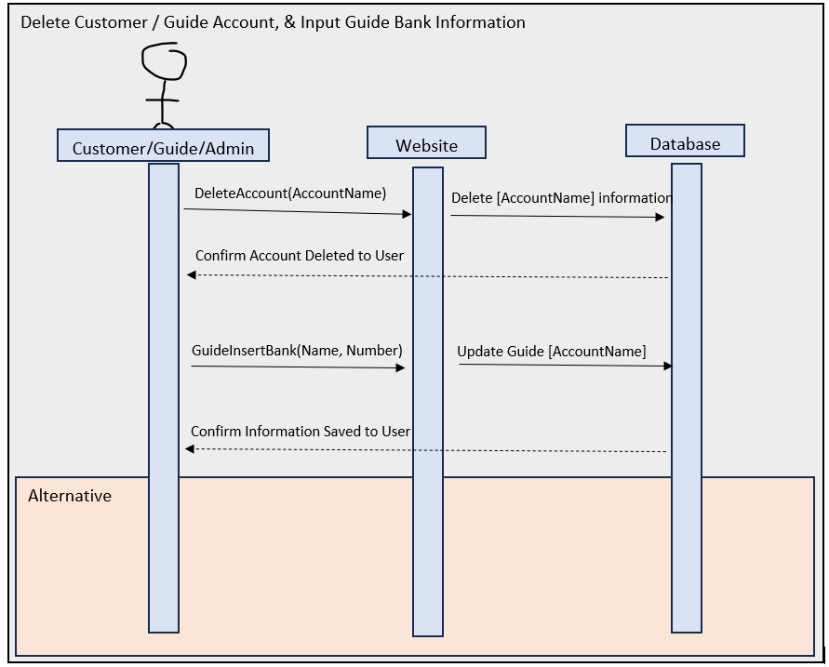

**Use Cases Diagram 26-28: Account Management**

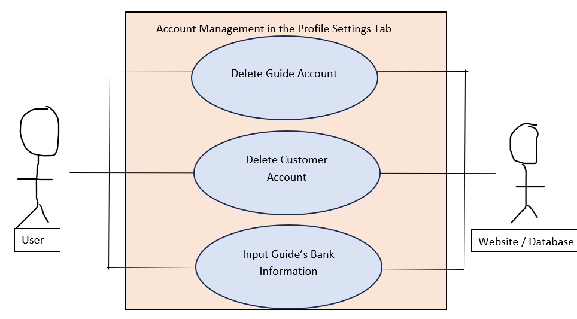

**Use Case 26-28 Diagram Narrative**

GuideBook Pro Members can manage their accounts through delete their customer/guide account as well as guides inputting their bank account information to receive payments for trips they hosted, as shown in this use-case diagram. In the settings, there will be a section called “Delete Account” with a warning explaining that the action cannot be undone, as well as a button. Clicking the button will give a confirmation popup that, when confirmed again, will delete the account from the system. Anytime a part of the website attempts to redirect to this account, it will instead show a default page stating that the account no longer exists. Additionally, another section available primarily for Guides will allow them to either manually input their bank account information, or link it with PayPal or Stripe. Regardless, this information will be visible to Administrators so that they can send trip payments to them.

**Use Case Description 29: Admin Pays Deposit**

|  |  |  |  |
| --- | --- | --- | --- |
| **Use Case Name**: Admin Pays Deposit | | **ID**: 29 | **Importance Level**: High |
| **Primary Actor**: Administrator | **Use Case Type**: Detail, Essential | | |
| **Stakeholders & Interests**:   * Administrator: Wants to manage the payment to pay the guide accurately * Guide: Wants to be paid as a sort of job, needs bank account information first | | | |
| **Brief Description**: This use case details how the administrator deposits payments to a guide’s bank account | | | |
| **Trigger**: Admin sends the payment deposit to the guide’s listed bank account    **Type**: External | | | |
| **Relationships**:   * **Association**: Administrator * **Include**: * **Extend**: Customer Pays Deposit * **Generalization**: Trip Overview | | | |
| **Normal Flow of Events**:   1. The administrator looks up recently completed trips on their side 2. The administrator looks for the respective guide(s), and searches for them 3. The administrator locates their bank account information, and begins the process of depositing money to them    1. Could be done via PayPal, Apple Pay, manually, etc. | | | |
| **Sub-Flows**: None | | | |
| **Alternate/Exceptional Flows**: None | | | |

**Use Case Description 30: Shares Experience**

|  |  |  |  |
| --- | --- | --- | --- |
| **Use Case Name**: Shares Experience | | **ID**: 30 | **Importance Level**: Low |
| **Primary Actor**: Customer | **Use Case Type**: Detail, Essential | | |
| **Stakeholders & Interests**:   * Customer: Wants to express how the trip went for them, including any concerns * Guide: Wants to know how the customers feel about a recent trip for review | | | |
| **Brief Description**: This use case details | | | |
| **Trigger**: Customer clicks “Share your experience” under the respective trip underneath Trip Overview in the Profile Settings    **Type**: External | | | |
| **Relationships**:   * **Association**: Customer * **Include**: * **Extend**: * **Generalization**: Trip Overview | | | |
| **Normal Flow of Events**:   1. The customer experiences the trip in-person first, then returns back home 2. The customer logs into their account 3. The customer clicks their profile, and goes to Profile Settings 4. The customer clicks Trip Overview, then selects the corresponding trip 5. Underneath the location name, the customer clicks “Share your experience“ 6. The customer types out a review/comment, then hits enter. | | | |
| **Sub-Flows**: None | | | |
| **Alternate/Exceptional Flows**: None | | | |

**Use Cases 29 & 30: Sequence Diagram**

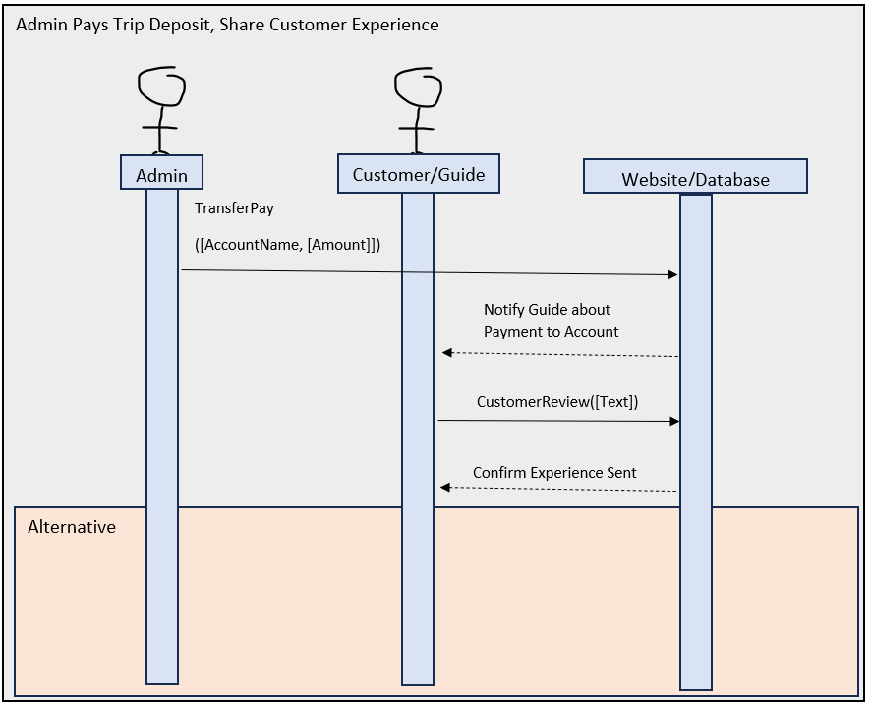

**Use Case Diagram 29-30:**

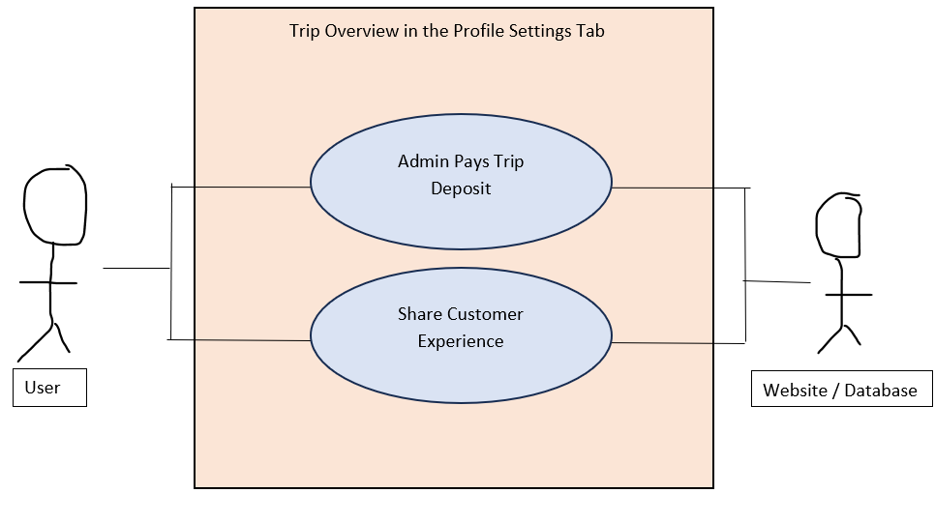

**Use Case 29-30 Diagram Narrative**

Also under account management, customers can share their trip experiences (leave reviews/comments) as well as managers being able to search for recent trips to locate the associated guide(s) so that they can process payments. On the customer side exclusively, a tab on the side called “Share Your Experience” will be visible. Click it, and the customer can select from their recent trips (most recent first; titled in the style of “Date of Trip - Trip Location (Guide names)”). Selecting one of these will take the customer to another page where they can submit pictures and text to share how the trip went. Other customers that went to similar trips, as well as the guides part of said trip, will be able to view these comments on the main page. On the administrator side exclusively, this will be replaced by a section called “Manage Trip Deposits.” When clicked, the admin will be redirected to a page where they can search for trips or guides by name/location, date/ID, as well as filter if the payment has already been fulfilled. If not, then the admin can click the guide/trip name (redirecting to the guides in the latter case) where they can see their payment information- either manual bank account information, or a link to their PayPal/Stripe account, where from there they can send payments.

# 3. Trace Matrix

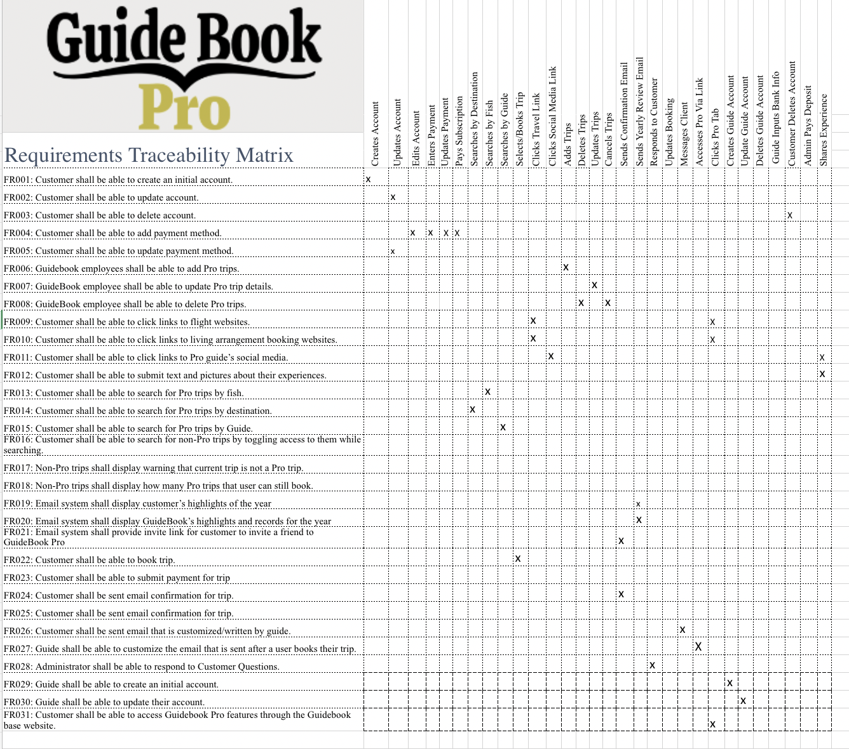  
[Excel Spreadsheet Link](https://cardmaillouisville.sharepoint.com/:x:/s/CodeCrusaders/EZLwHRgeeStNtlf49w2rdrABvH54eChQaJR3ugLGpV_-VQ?e=Bnfx3j)

# 4. Class Diagram & Narrative

Class Diagram Narrative

## Our class diagram breaks down and explains each of the objects that are going to be involved in our database, as well as the relationships that each object will have with each other. We created this diagram by starting with all of the possible actors that could have a role to play in our database. To get our diagram to be in the third normalization form, which essentially helps us to reduce data duplication, anomalies, and improve the overall simplicity of our design, we created certain classes, such as Messages and TripBookings. Having these classes will help us keep things straight.

Each of our classes will have a list of attributes underneath them. These attributes will provide the user with a description of each of the classes and how we have defined them. Some classes have more attributes than others, and this is normal due to the aforementioned process that we used in order to define our classes.

The relationships between classes are depicted by the lines that connect each class. The different numbers that are on either side of the line are examples of cardinality. This is the number of ways that one class can relate to another. For example, a guide can offer one or many trip listings, but a trip listing can only be offered by one guide. The 0 means none, the 1 means one, and the * means many. The verbs that are in the middle of each relationship line are how the actual classes are related.

Class Diagram

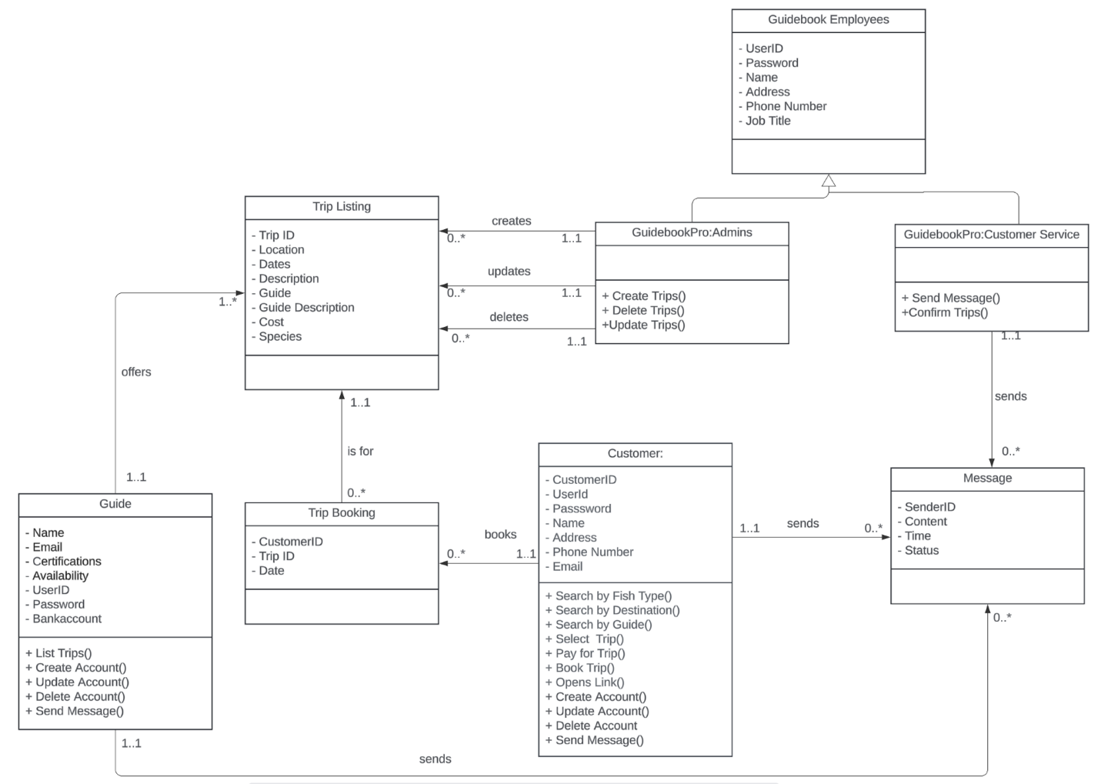

# 5. Database Diagram & Narrative

Database Narrative

Each class in our class diagram received a table in the database design. Each table stores important information that GuideBook wants to store about that particular class. The tables will also relate to each other. Each entry in the messages table will have a SenderID to connect it to whichever employee, customer, or guide sent the message. Many trip listings offer multiple dates. Therefore, they relate to multiple customers. Customers can, and should, book multiple trips. To resolve this many-to-many relationship, a trip booking table exists to hold each customer booking. Partial Dependency was not an issue as the only table with two primary keys was Trip Booking, whose only other attribute Date relates to both primary keys. Transitive Dependency was avoided when designing the class diagram.

Database Diagram

# A diagram of a computer Description automatically generated 6. Database Definitions

**Trip Listings**

|  |  |  |  |  |
| --- | --- | --- | --- | --- |
| Attribute | Definition | Type | Size | Key |
| Trip ID | Unique identifier for the trip. | Int | 4 bytes | Primary |
| Location | Trip Location | String | 4 bytes | No |
| Dates | Trip Date | Date | 3 bytes | No |
| Description | Description of trip | String | 126 bytes | No |
| Guide | Trip Guide | String | 8 bytes | No |
| Cost | Trip Price | Float | 255 bytes | No |
| Species | Types of fish | String | 255 bytes | No |

**Trip Booking**

|  |  |  |  |  |
| --- | --- | --- | --- | --- |
| Attribute | Definition | Type | Size | Key |
| Trip ID | Unique identifier for the trip. | Int | 4 bytes | Primary, Foreign |
| Customer ID | Trip Location | String | 4 bytes | Primary, Foreign |
| Date | Date of booking | Date | 3 bytes | No |

**Guidebook Pro Employees**

|  |  |  |  |  |
| --- | --- | --- | --- | --- |
| Attribute | Definition | Type | Size | Key |
| User ID | Employees User ID | Int | 4 bytes | Primary |
| Password | Employee’s password | String | 8 bytes | No |
| Name | Employees name | String | 4 bytes | No |
| Address | Employees address | Int | 4 bytes | No |
| Phone number | Employees number | Int | 8 bytes | No |
| Job title | Job title | String | 8 bytes | No |

**Guide**

|  |  |  |  |  |
| --- | --- | --- | --- | --- |
| Attribute | Definition | Type | Size | Key |
| Name | Guide’s name | String | 4 bytes | No |
| Email | Guide’s email | String | 8 bytes | No |
| Certifications | Guide’s certifications. | String | 128 bytes | No |
| Description | Description of the Guide | String | 256 bytes | No |
| Availability | Guides Availability | String | 4 bytes | No |
| User ID | Guides user Id | String | 4 bytes | Primary |
| Bank account | Guides account | Int | 8bytes | No |

**Customer**

|  |  |  |  |  |
| --- | --- | --- | --- | --- |
| Attribute | Definition | Type | Size | Key |
| Customer ID | Unique Identifier for the customer | Int | 4 bytes | Primary |
| User ID | User ID | Int | 4 bytes | No |
| password | Customers pass | String | 8 bytes | No |
| Name | Customers name | String | 4 bytes | No |
| Address | Address of customer | Int | 4 bytes | No |
| Email | Email of customer | String | 512 bytes | No |

**Messages**

|  |  |  |  |  |
| --- | --- | --- | --- | --- |
| Attribute | Definition | Type | Size | Key |
| Sender ID | Identifier of the sender | Int | 4 bytes | Primary, Foreign |
| Content | Message content | String | 512 bytes | No |
| Time | Time message was sent | Date | 3 bytes | No |
| Status | Status of Message | String | 4 bytes | No |

# 7. User Interface Navigation Diagram & Narrative

User Interface Diagram Narrative

## Above is a Window Navigation Diagram. The diagram shows the system we would create for GuideBook Pro at its most basic level. It shows the basic components of the entire system, and the interactions that a potential user would have with the website, and the interactions that the website would have itself.

User Interface Navigation Diagram

# 8. Screen Layouts

### 8.3A Search Screens/Forms

## **Search By Destination, Fish, and/or Guide**

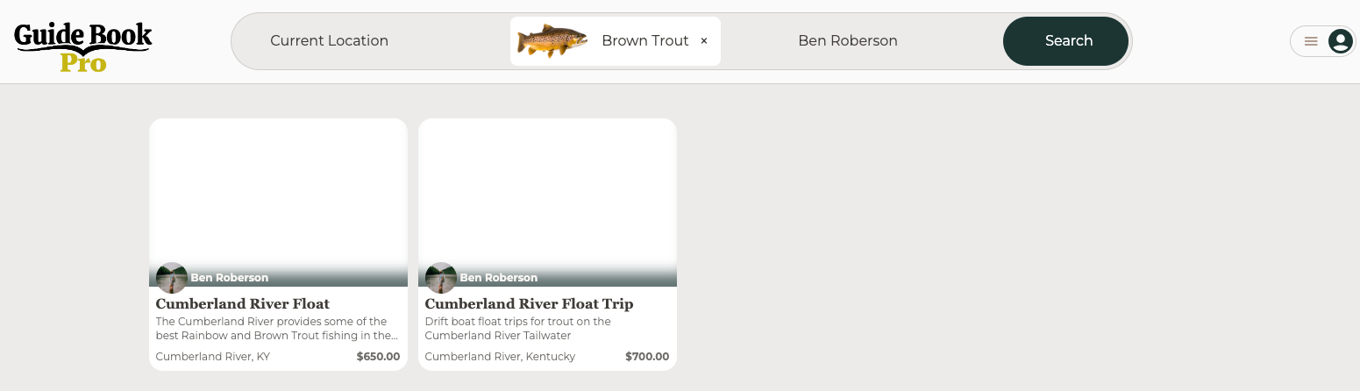

This search form allows the user to search for trips by location, fish species, and guide. The user can utilize any combination of search criteria to find their desired trip. Here, the user has searched for trips near their current location, for Brown Trout, with the guide Ben Roberson and has found two results.

## **Trip Selection**

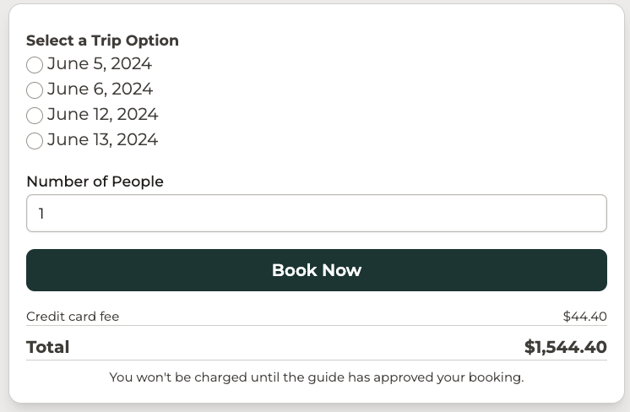

This form, which is on each trip details page, allows the user to select the date of their trip and the number of people they wish to bring on the trip. They can see the full price of the trip and select the “Book Now” button to book their trip.

### 8.3B Profile Screens/Forms

## **Edit and Delete Profile**

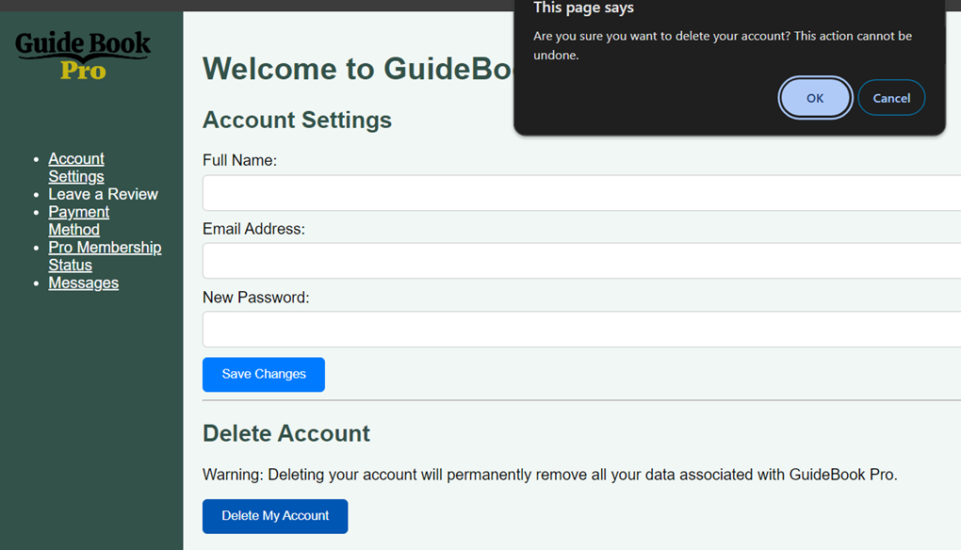

This form allows the user to edit information about their account. On this particular form, the user can edit their name and email address and create a new password. This form also enables the user to delete their profile. In order to prevent accidental account deletion, a warning box appeared in the top right corner asking the user to confirm that they wish to delete their account.

### 8.3C Cart Screens/Forms

## **Checkout**

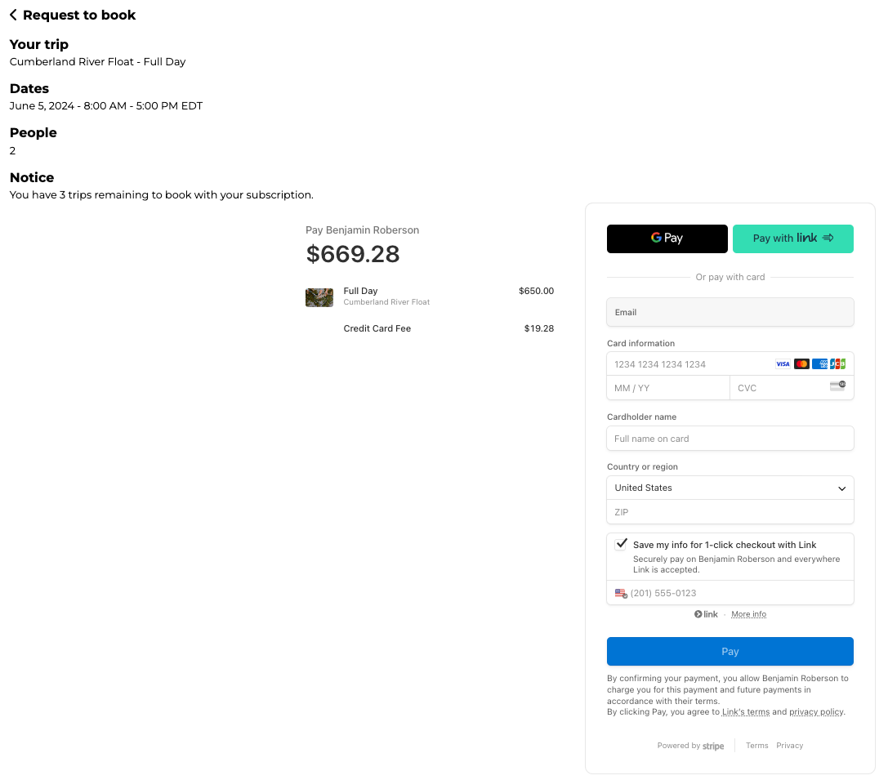

This form allows the user to checkout with their selected trip by inserting their payment information. They are presented with all the information about their upcoming trip. In addition, they are given a notice about how many trips they have remaining to book with their GuideBook Pro subscription.

# 9. Gantt Chart

* [Excel Spreadsheet Link](https://cardmaillouisville.sharepoint.com/:x:/s/CodeCrusaders/EfnHf91RJJlGgTBB3MuXzl8BzwDJnqrZhsxFmQAc9ai-cw?e=uO58zg)

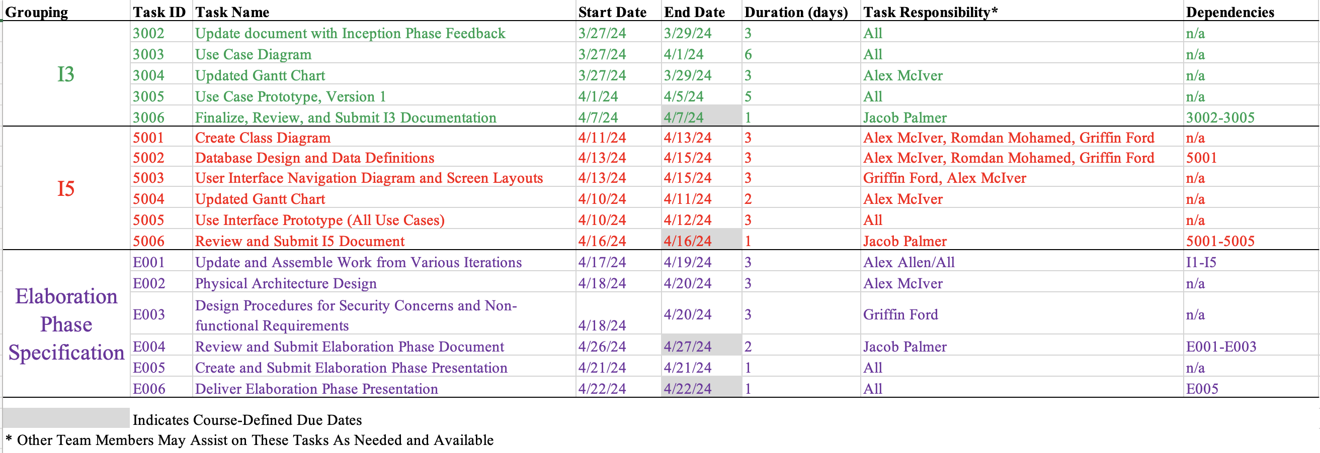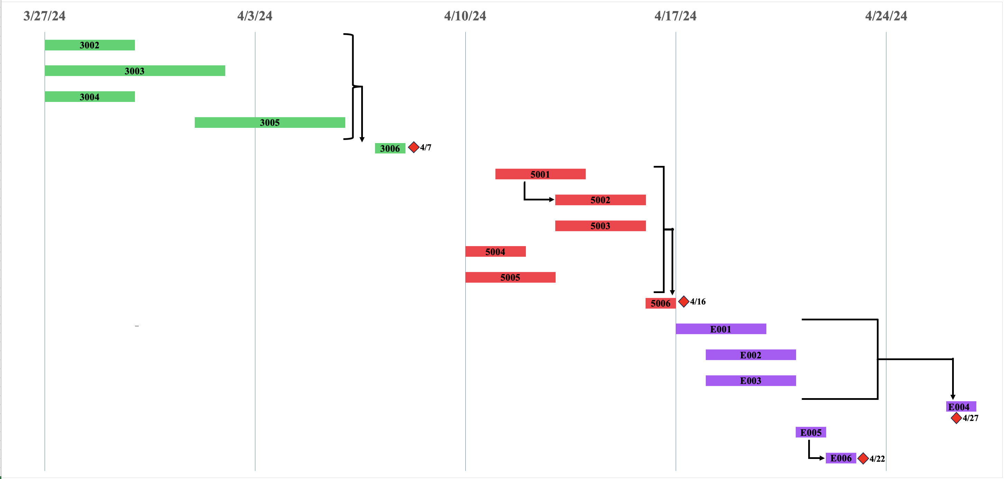Gantt Chart Narrative

This Gantt Chart allows our team to organize the tasks required to complete iteration two, the inception phase, and iteration three. It allows us to view the duration of each task and the task(s) that must be completed before another task can be completed. As diagramed above, we have outlined the following tasks:

10. Physical Architecture Design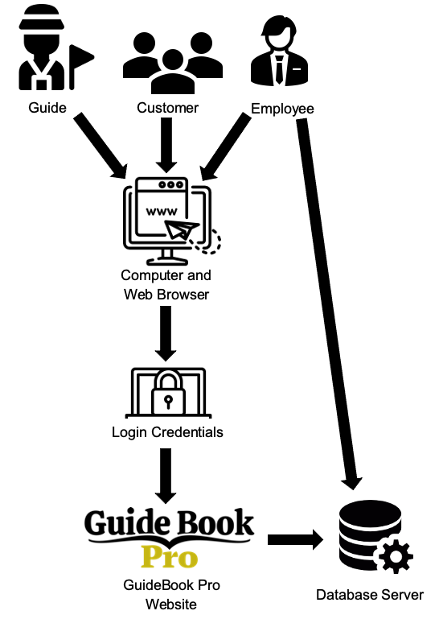

The physical architecture design shows how all users, including guides, customers, and employees, will access the GuideBook Pro system. All users will access the site using a computer with a web browser. They will need to insert their login credentials to access the GuideBook Pro website. The users’ actions on the website (booking trips, changing prices, writing trip descriptions, updating profiles, and many more) will be reflected in the database server. In addition, GuideBook employees can also directly access the database server to make necessary inserts, updates, and deletions.

# 11. Design Procedures for Security Concerns & **Nonfunctional Requirements**

In our prototype, we've integrated several features to address the security concerns within our Guidebook project. We recognize the paramount importance of data security, as any compromise or inaccuracies could profoundly impact our team's success and reflect poorly on our organization.

The primary feature we've implemented is Two-Factor Authentication. To access our website, users must confirm their identity through Two-Factor Authentication, utilizing the code sent to their Guidebook-registered email. This stringent measure ensures that only authorized individuals have access to our data, thereby safeguarding its integrity and confidentiality.

Another significant feature is the implementation of permission levels for staff members. Those assigned the administrator role possess exclusive privileges to edit and delete data. This precautionary measure guarantees the accuracy and reliability of our data, preventing erroneous conclusions that could undermine our team's efforts.

By incorporating these measures, we've effectively addressed the security concerns inherent in our Guidebook project, ensuring the safety and reliability of our data throughout its lifecycle.

# 12. Elaboration Phase Prototypes

**Use Case 1: Creates Account**

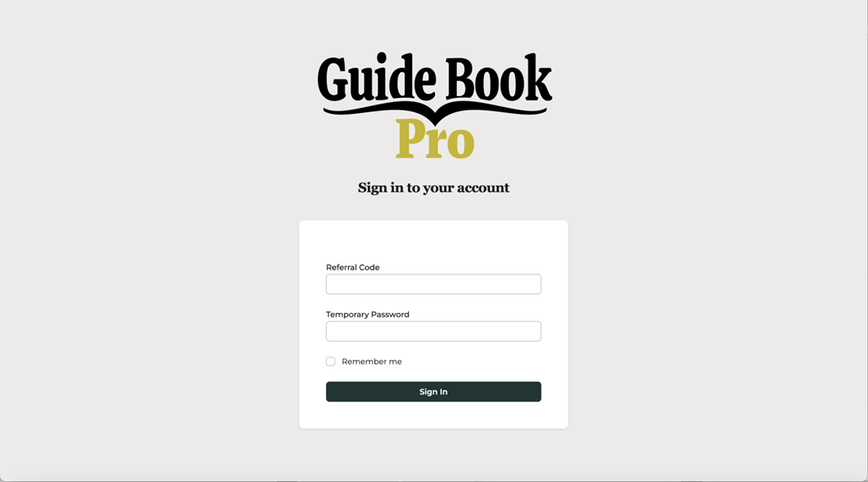

**Use Case 2: Updates Account**

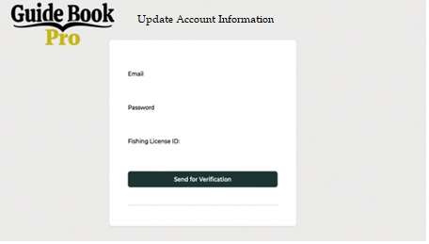

**Use Case 3: Edits Account**

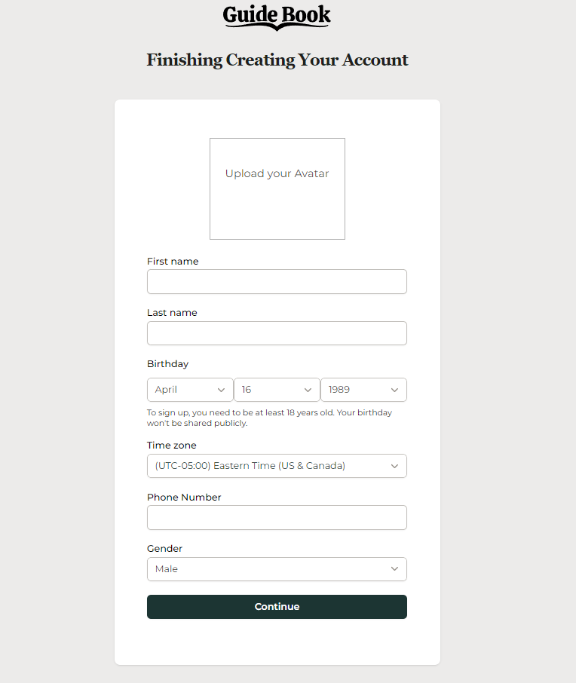

**Use Case 4: Enters Payment**

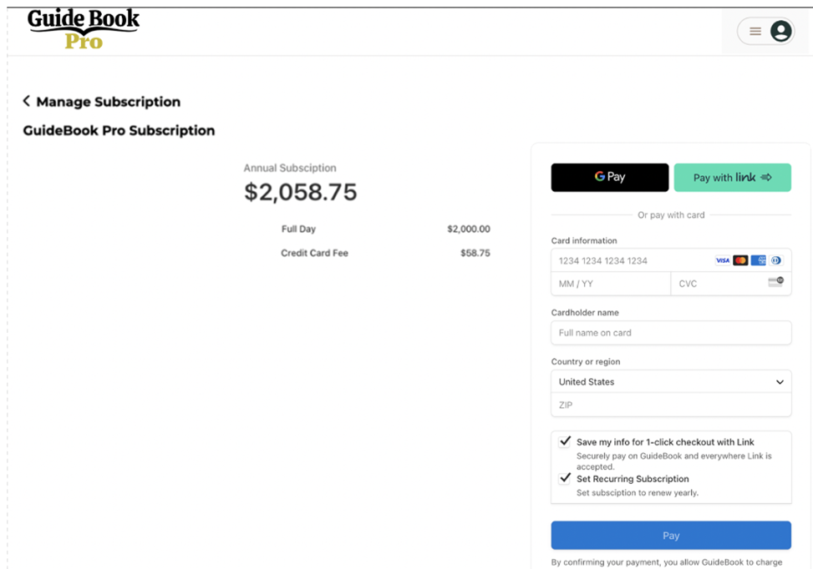

**Use Case 5: Updates Payment**



**Use Case 6: Pays Subscription**



**Use Case 7: Searches by Destination**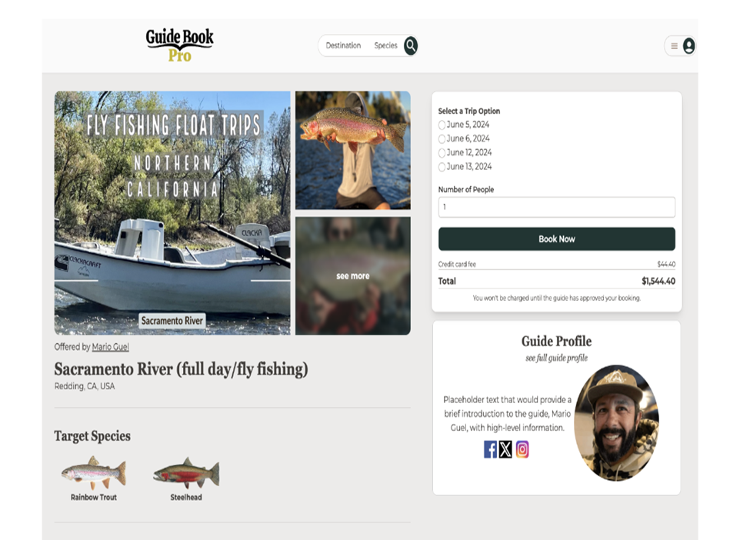

**Use Case 8: Searches by Fish**

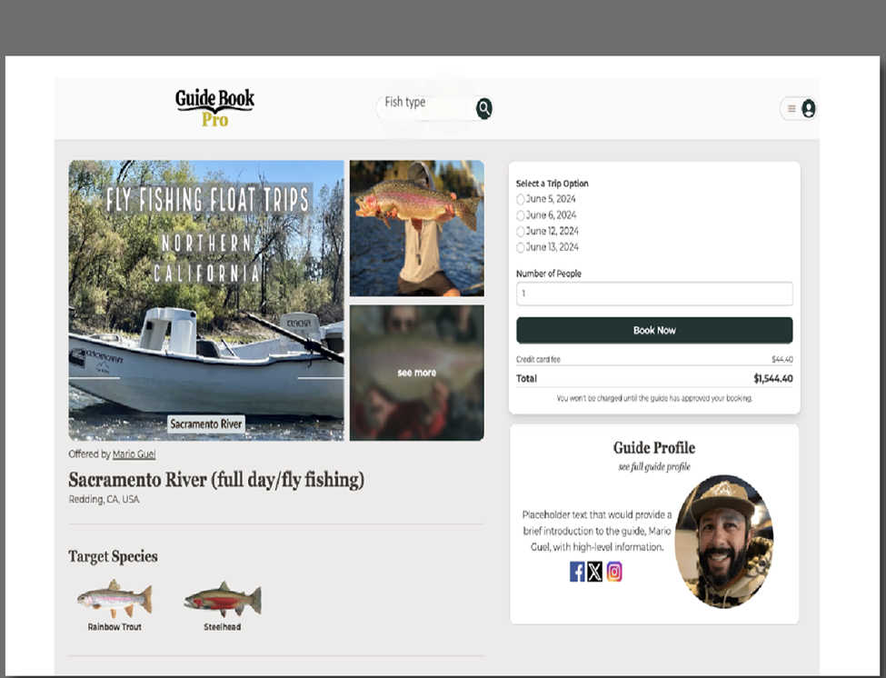

**Use Case 9: Searches by Guide**

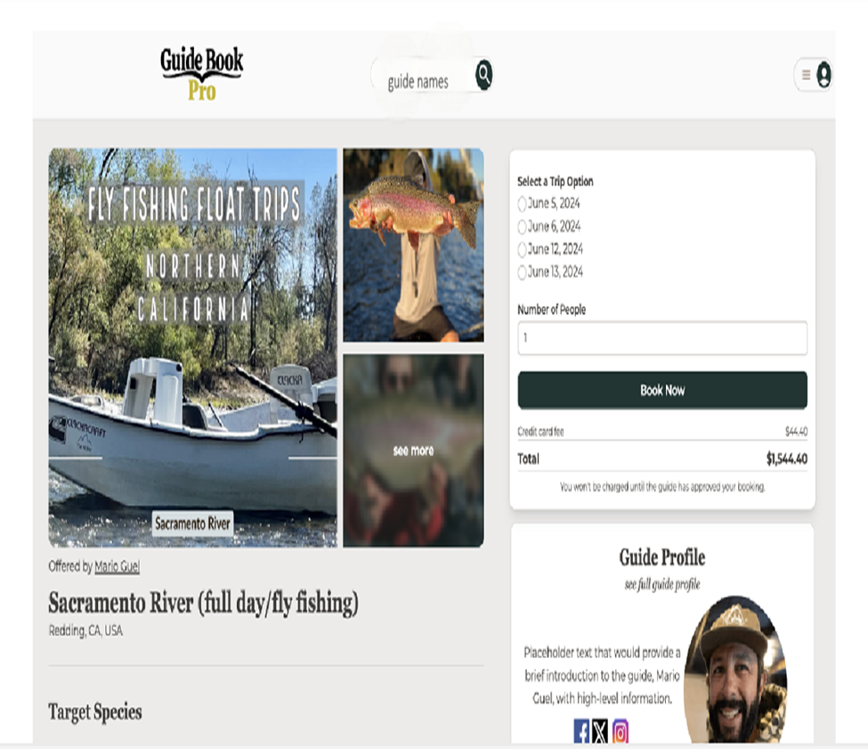

**Use Case 10: Selects/Books Trip**

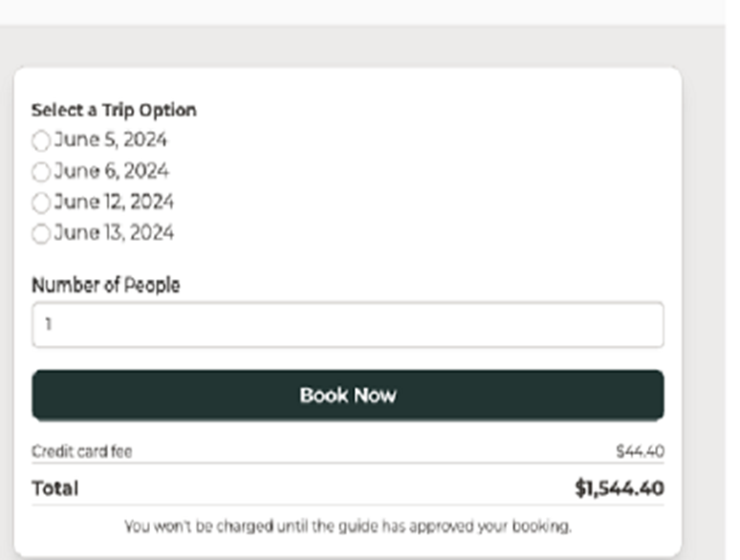

**Use Case 11: Clicks Travel Link**

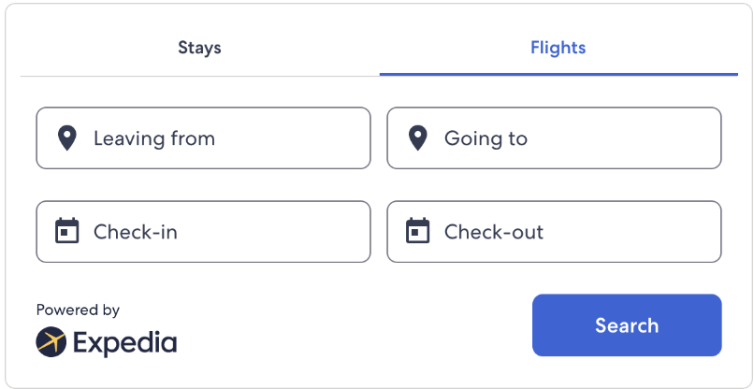

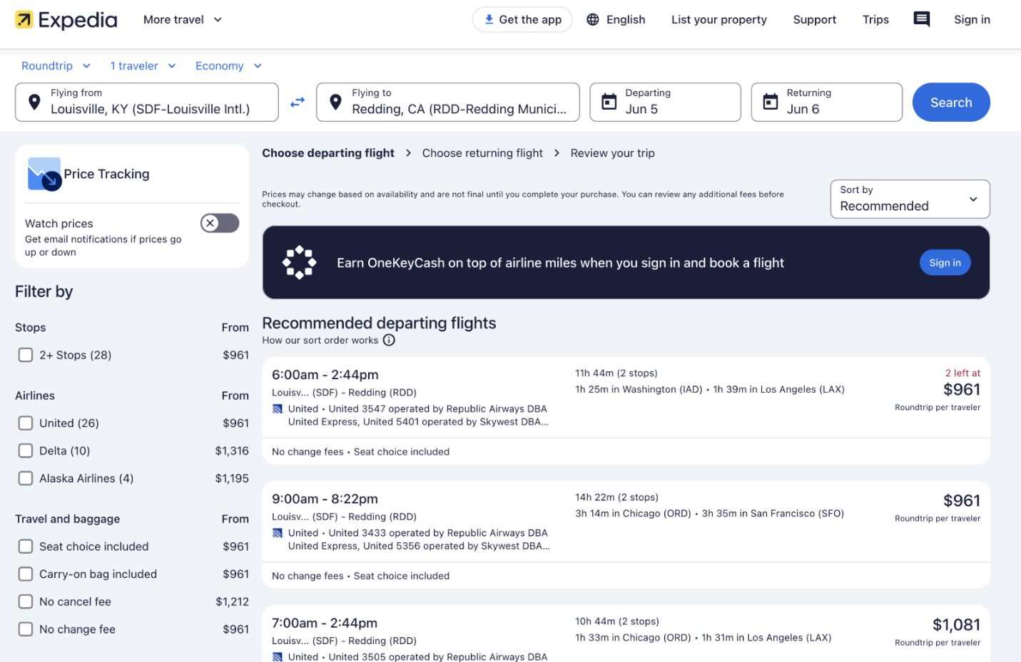

**Use Case 12:Clicks Social Media Link**

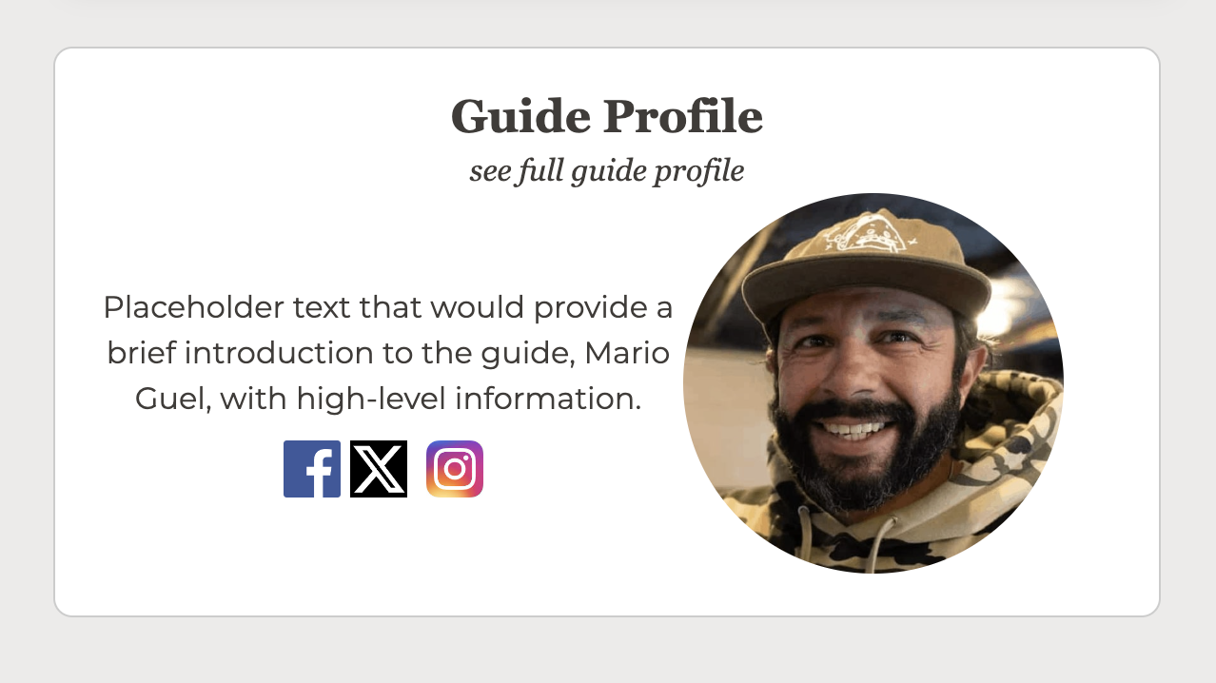

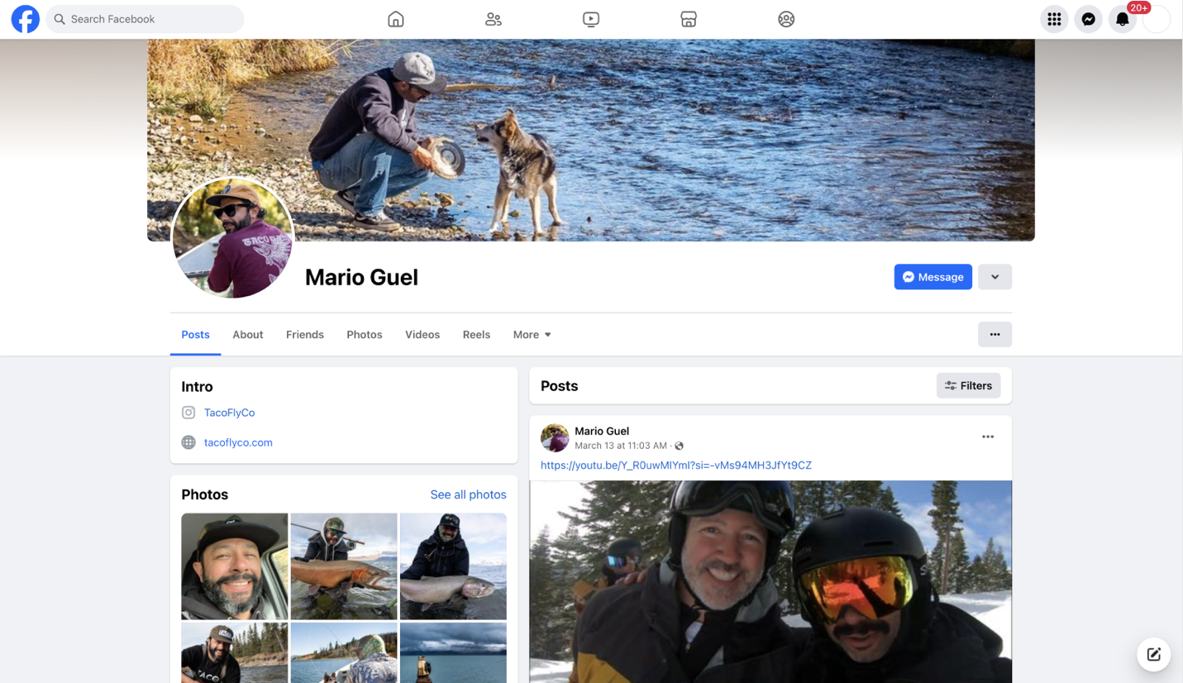

**Use Case 13: Adds Trips**

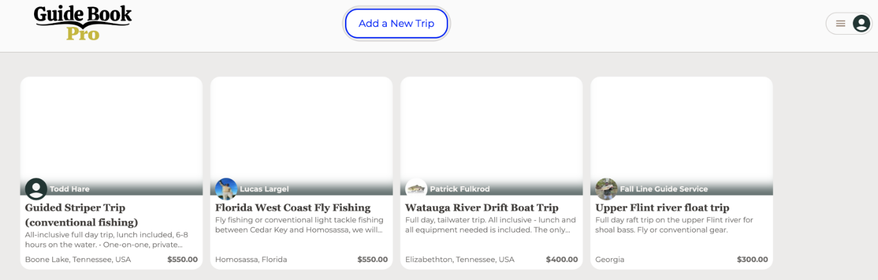

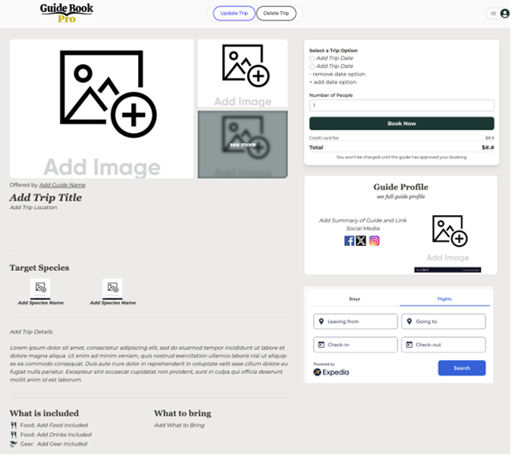

**Use Case 14: Deletes Trips**

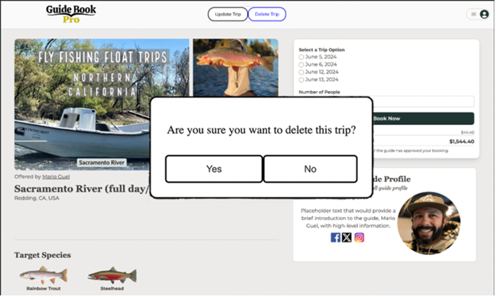

**Use Case 15: Updates Trip**

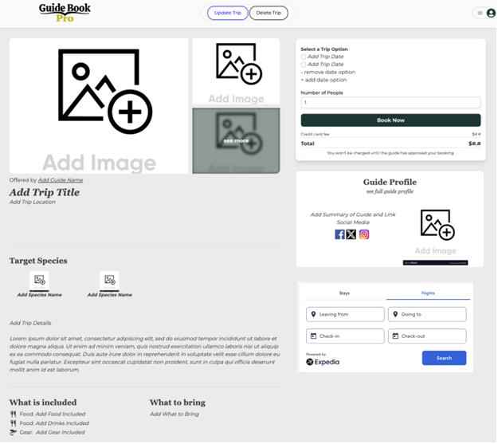

**Use Cases 16 and 20: Cancels and Updates Booking**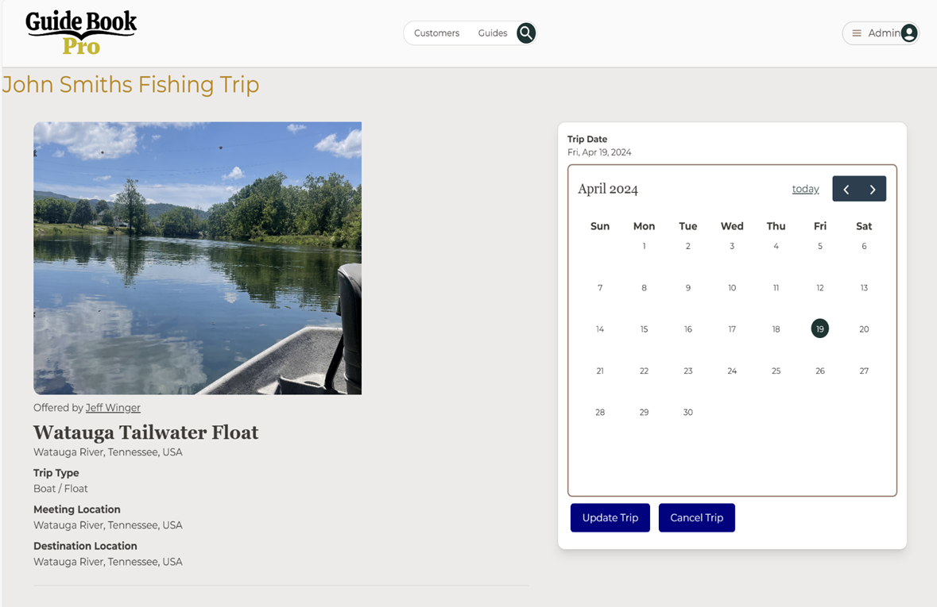

**Use Case 17: Sends Confirmation Email**

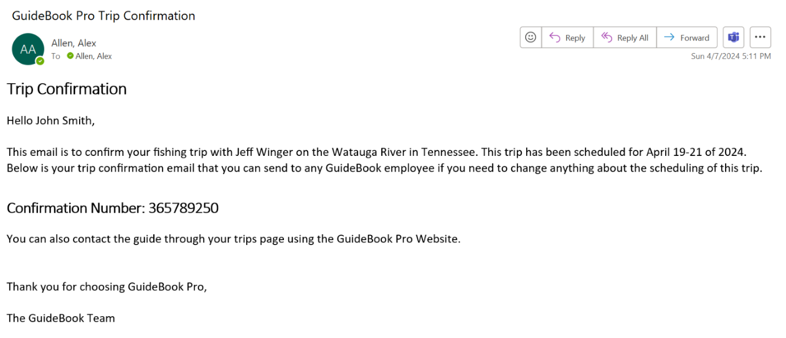

**Use Case 18: Sends Yearly Review Email**

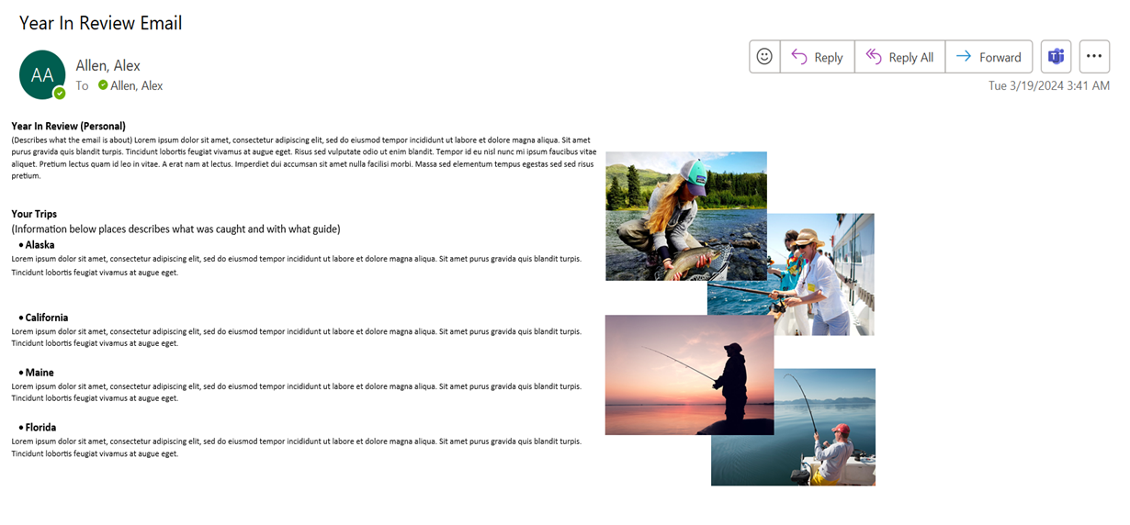

**Use Case 19: Responds To Customers**

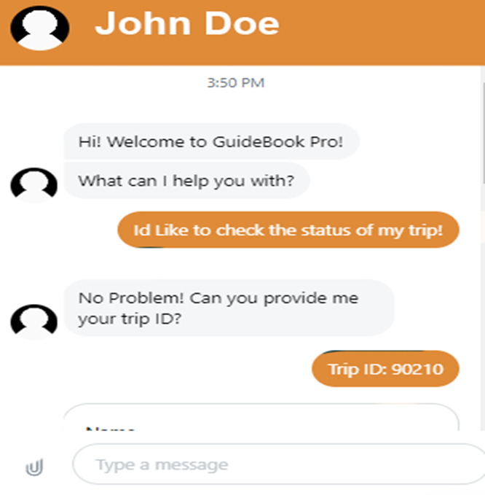

**Use Case 21: Messages Client**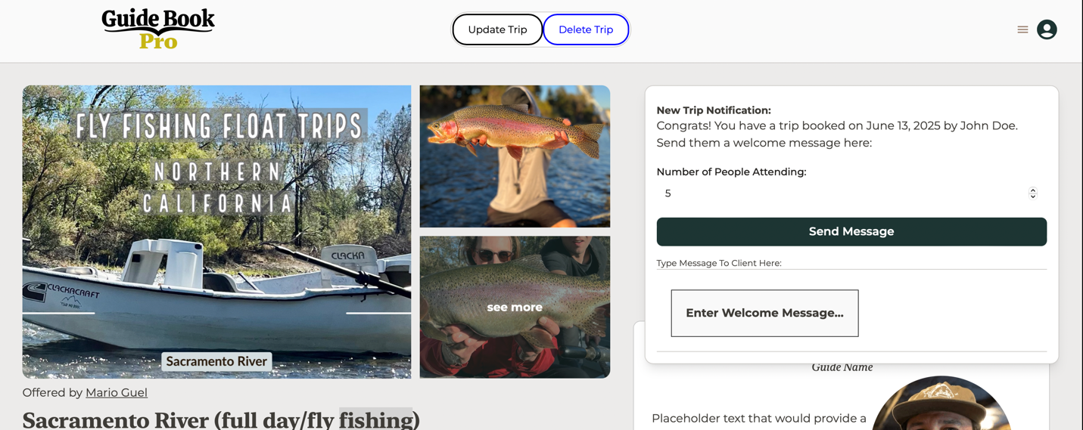

**Use Case 22: Accesses Pro Via Link**

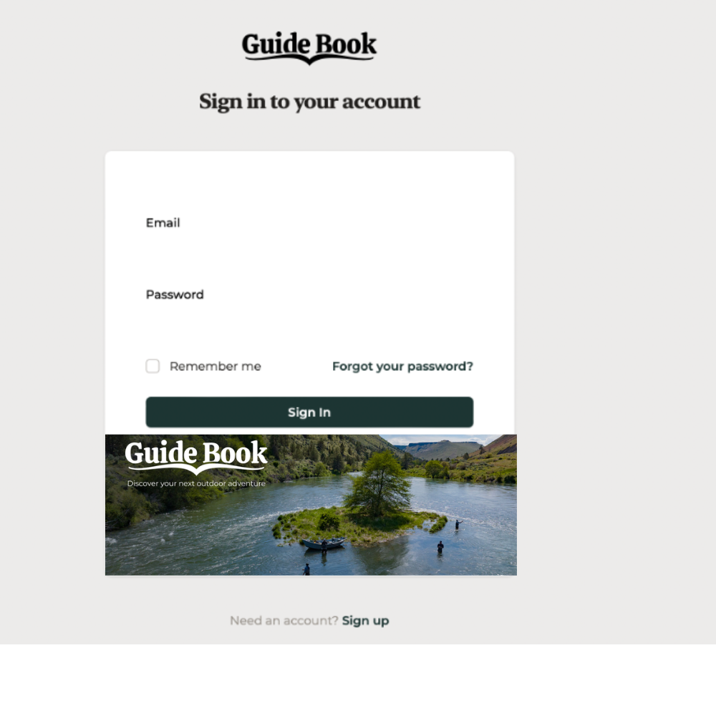

**Use Case 23: Clicks Pro Tab**

**Use Case 24: Creates Guide Account**

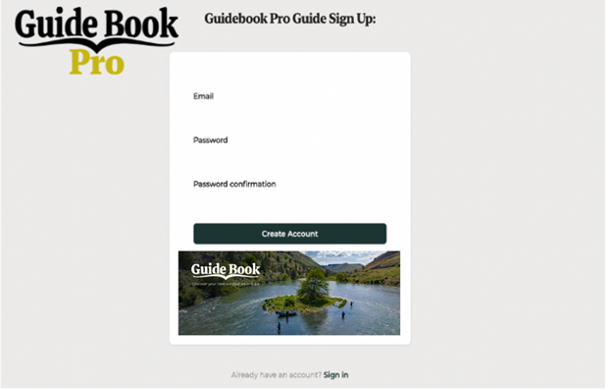

**Use Case 25: Updates Guide Account**

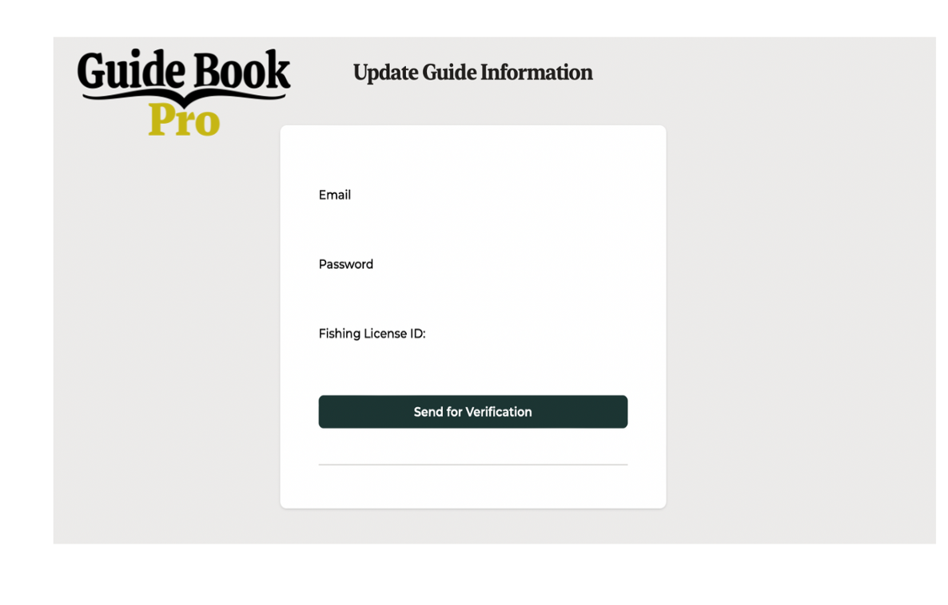

**Use Case 26: Deletes Guide Account and Use Case 28: Customer Deletes Account**



**Use Case 27: Guide Inputs Bank Info**

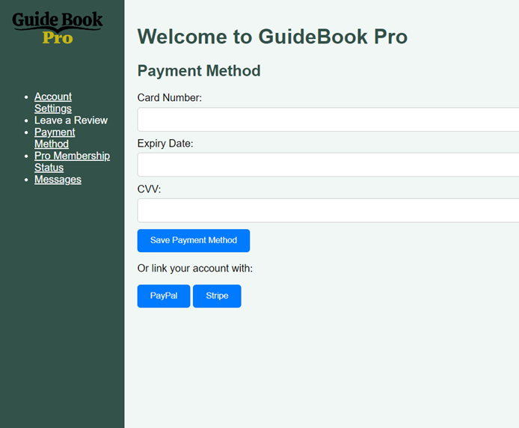

**Use Case 29: Pays Deposit**

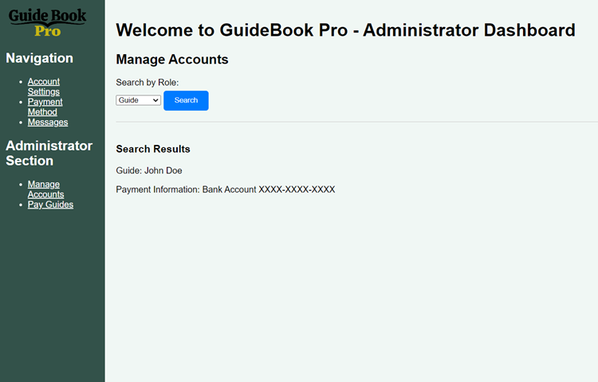

**Use Case 30: Shares Experience**

